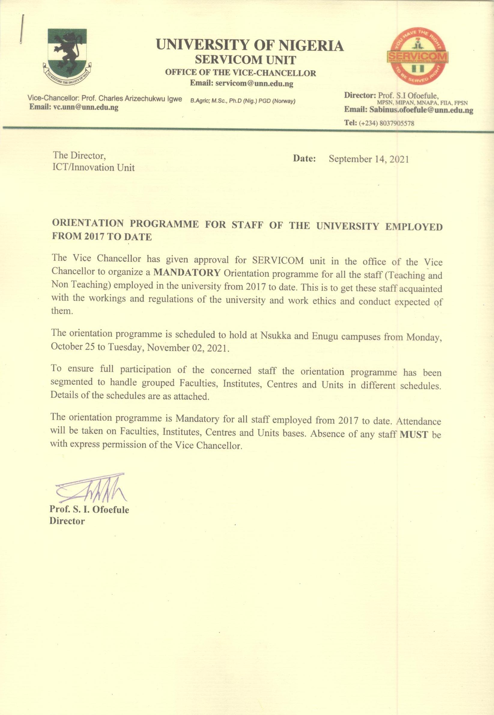

**UNIVERSITY OF NIGERIA**

**SERVICOM UNIT**

**OFFICE OF THE VICE-CHANCELLOR**

**ORIENTATION PROGRAMME FOR NEW STAFF OF THE UNIVERSITY OF NIGERIA**

**EMPLOYED FROM 2017 – 2020: REQUEST FOR APPROVAL**

**Centre:** University of Nigeria, Nsukka

**Group:** Academic Staff

**Date:** Monday, October 25 – Tuesday, October 28, 2021

|  |  |  |  |  |  |  |  |  |
| --- | --- | --- | --- | --- | --- | --- | --- | --- |
| **S/NO.** | **VENUE** | **FACULTY/GROUP** | **DATE** | **TOPIC** | **TIME** | **No. of Participant** | **CHAIR PERSONS** | **PRESENTER** |
| 1 | Ekpo Convocation Arena | Agriculture, Arts, Biological Sciences, Education and School of General Studies (SGS) | 25/10/2021 | Opening Ceremony | 10.00 – 10.30 a.m. | 414 | Vice Chancellor Prof. C. I. Igwe | |
| Morality: Staff –student relationship | 10.30 – 11.30 am | 414 | Prof. Pat Okpoko  (DVC Admin) | Prof. S.I. Ofoefule, Director, SERVICOM |
| Staff Regulations Guiding Conditions of Service | 11.30 – 12.30pm | 414  414 | “ | Registrar, Barr. Chris Igbokwe |
| **B R E A K** | **12.00 – 1.30 p.m** |  |  |  |
| Work Ethics | 1.30 – 2.30 p.m | 414  414 | “ | Director of Ethics |
| Evaluation of academic activities | 2.30 – 3.30pm | 414 | “ | Director of Quality Assurance |
| 2 | Ekpo Convocation Arena | Engineering, Pharmaceutical Sciences, Physical Sciences, Veterinary Medicine, Vocational and Technical Education, Nnamdi Azikiwe Library, Institutes, Centres and Units | 26/10/2021 | Morality: Staff – student relationship | 10.00 – 11.00 a.m. | 402 | Prof. J. Uramah (DVC –Academics) | Prof. S.I. Ofoefule, Director, SERVICOM Unit |
| Staff Regulations Guiding Conditions of Service | 11.00 – 12.00noon | 402  402 | “ | Registrar, Barr. Chris Igbokwe |
| **B R E A K** | **12.00 – 1.30 p.m** |  |  |  |
| Work Ethics | 1.30 – 2.30 p.m | 402 | “ | Director of Ethics |
| Evaluation of academic activities | 2.30 – 3.30pm | 402  402 | “ | Director of Quality Assurance |

**UNIVERSITY OF NIGERIA**

**SERVICOM UNIT**

**OFFICE OF THE VICE-CHANCELLOR**

**ORIENTATION PROGRAMME FOR NEW STAFF OF THE UNIVERSITY OF NIGERIA**

**EMPLOYED FROM 2017 – 2020: REQUEST FOR APPROVAL**

**Centre:** University of Nigeria, Nsukka

**Group:** Non**-**Academic Staff

**Date:** Wednesday, October 26– Thursday, October 28, 2021

|  |  |  |  |  |  |  |  |  |
| --- | --- | --- | --- | --- | --- | --- | --- | --- |
| **S/NO.** | **VENUE** | **FACULTY/GROUP** | **DATE** | **TOPIC** | **TIME** | **No. of Participant** | **CHAIR PERSONS** | **PRESENTER** |
| 1 | Ekpo Convocation Arena | All Faculties, Nnamdi Azikiwe Library, School of General Studies (SGS) and Medical Centre | 27/10/2021 | Morality: Staff – student relationship | 10.00 – 11.00 a.m. | 793 | Dr. Jude Edeh  Bursar | Prof. S.I. Ofoefule, Director, SERVICOM Unit |
| Staff Regulations Guiding Conditions of Service | 11.00 – 12.00noon | 793 | ” | Registrar, Barr. Chris Igbokwe |
| **B R E A K** | **12.00 – 1.30 p.m** |  |  |  |
| Work Ethics | 1.30 – 2.30 p.m | 793 | “ | Director of Ethics |
| Evaluation of academic activities | 2.30 – 3.30pm | 793 | “ | Director of Quality Assurance |
| 2 | Ekpo Convocation Arena | All Institutes, Centres, Units, Works, School of Postgraduate Studies (SPGS), Students’ Affairs, Registry, Bursary and Security | 28/10/2021 | Morality: Staff – student relationship | 10.00 – 11.00 a.m. | 793 | Dr. (Mrs.) Ilo  University Librarian | Prof. S.I. Ofoefule, Director, SERVICOM Unit |
| Staff Regulations Guiding Conditions of Service | 11.00 – 12.00noon | 793 | “ | Registrar, Barr. Chris Igbokwe |
| **B R E A K** | **12.00 – 1.30 p.m** |  |  |  |
| Work Ethics | 1.30 – 2.30 p.m | 793 | “ | Director of Ethics |
| Evaluation of academic activities | 2.30 – 3.30pm | 793 | “ | Director of Quality Assurance |

**UNIVERSITY OF NIGERIA**

**SERVICOM UNIT**

**OFFICE OF THE VICE-CHANCELLOR**

**ORIENTATION PROGRAMME FOR NEW STAFF OF THE UNIVERSITY OF NIGERIA**

**EMPLOYED FROM 2017 – 2020: REQUEST FOR APPROVAL**

**Centre:** University of Nigeria, Enugu Campus

**Group:** Academic and Senior Administrative Staff

**Date:** Monday, November 01 – Tuesday, November 02, 2021

|  |  |  |  |  |  |  |  |  |
| --- | --- | --- | --- | --- | --- | --- | --- | --- |
| **S/NO.** | **VENUE** | **FACULTY/GROUP** | **DATE** | **TOPIC** | **TIME** | **No. of Participant** | **Chair Person** | **PRESENTER** |
| 1 | Main Hall, UNEC | All Faculties, Institute, Centres, Units, Academic Staff and Senior Administrative Staff | 01/11/2021 | Morality: Staff – student relationship | 10.00 – 11.00 a.m. | 793 | Prof. Edith Nwosu  DVC-UNEC | Prof. S.I. Ofoefule, Director, SERVICOM Unit |
| Staff Regulations Guiding Conditions of Service | 11.00 – 12.00noon | 793 | “ | Registrar, Barr. Chris Igbokwe |
| **B R E A K** | **12.00 – 1.30 p.m** |  |  |  |
| Work Ethics | 1.30 – 2.30 p.m | 793 | “ | Director of Ethics |
| Evaluation of academic activities | 2.30 – 3.30pm |  | “ | Director of Quality Assurance |
| **Group: Non-Academic Staff** | | | | | | | | |
| 2 | Main Hall, UNEC | Senior Technology Staff, Junior Staff and Medical Centre | 2/11/2021 | Morality: Staff – student relationship | 10.00 – 11.00 a.m. | 793 | Prof. Uchenna Nwagha  Provost, COM | Prof. S.I. Ofoefule, Director, SERVICOM Unit |
| Staff Regulations Guiding Conditions of Service | 11.00 – 12.00noon | 793 | “ | Registrar, Barr. Chris Igbokwe |
| **B R E A K** | **12.00 – 1.30 p.m** |  |  |  |
| Work Ethics | 1.30 – 2.30 p.m | 793 | “ | Director of Ethics |
| Evaluation of academic activities | 2.30 – 3.30pm |  | “ | Director of Quality Assurance |