Paper Title (use style: paper title)
Subtitle as needed

Authors Name/s per 1st Affiliation (Author)
line 1 (of Affiliation): dept. name of organization
line 2: name of organization, acronyms acceptable
line 3: City, Country
line 4: e-mail: name@xyz.com
Authors Name/s per 2nd Affiliation (Author)
line 1 (of Affiliation): dept. name of organization
line 2: name of organization, acronyms acceptable
line 3: City, Country
line 4: e-mail: name@xyz.com

Abstract—This document is a sample CERTIP 2021 paper preparation template. The various components of your paper [title, text, heads, etc.] are expected to span between 4 and 6 pages, as illustrated by the portions given in this document. DO NOT USE SPECIAL CHARACTERS, SYMBOLS, OR MATH IN YOUR TITLE OR ABSTRACT.
Keywords- manuscript template; component; formatting; style; styling (not more than 5)

Introduction (Heading 1)
You are strongly advised to stick to this template in preparing your manuscript to avoid feedback delays. All manuscripts must be in English. These guidelines include complete descriptions of the fonts, spacing, and related information for producing CERTIP-21 proceedings manuscripts. Please follow them.
Authors can directly adopt most of the formatting specifications in this template for their papers. All the paper components have been specified for three reasons: (1) ease of use when formatting individual papers, (2) automatic compliance to electronic requirements that facilitate the concurrent or later production of electronic versions, and (3) conformity of style throughout a conference proceedings. Margins, column widths, line spacing, and type styles are expected to be same for all papers. PLEASE DO NOT RE-ADJUST THESE MARGINS.
Wherever Times is specified, Times Roman or Times New Roman may be used. If neither is available on your word processor, please use the Times new Roman. Avoid using bit-mapped fonts if possible. True-Type 1 or Open Type fonts are preferred. Please embed symbol fonts, as well, for math, etc.

Methodology

Maintain this Template (Heading 2)
First, confirm that you have the correct template for your paper size. Try and use A4-sized paper, font 12 in preparing your paper.

Maintaining the Integrity of the Specifications
The template is used to format your paper and style the text. All margins, column widths, line spaces, and text fonts are prescribed; please do not alter them. Prepare Your Paper Before Styling
Before you begin to format your paper, first write and save the content as a separate text file. Keep your text and graphic files separate until after the text has been formatted and styled. Do not use hard tabs, and limit use of hard returns to only one return at the end of a paragraph. Do not add any kind of pagination anywhere in the paper.

Please, take note of the following items when proofreading spelling and grammar:

Abbreviations and Acronyms
Define abbreviations and acronyms the first time they are used in the text, even after they have been defined in the abstract. Abbreviations such as ASME, SI, MKS, CGS, sc, dc, and rms do not have to be defined. Do not use abbreviations in the title or heads unless they are unavoidable.

Units
Use SI (MKS) as primary units. (SI units are encouraged.) English units may be used as secondary units (in parentheses). An exception would be the use of English units as identifiers in trade, such as “3.5-inch disk drive”.

Equations
The equations are an exception to the prescribed specifications of this template. You will need to determine whether or not your equation should be typed using either the Times New Roman or the Symbol font (please no other font). Number equations consecutively. Equation numbers, within parentheses, are to position flush right, as in (1), using a right tab stop. Punctuate equations with commas or periods when they are part of a sentence, as in

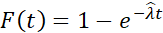 (1)
Be sure that the symbols in your equation have been defined before or immediately following the equation. Use “(1)” in the middle of sentences, not “Eq. (1)” or “equation (1)”, except at the beginning of a sentence: “Equation (1) is . . .”

Results and discussion
Present the most significant and detailed achievement of the paper and how the results answered the objectives. Where charts and Tables are used, explanations may be necessary to drive home the significance of each and enhance understanding of a wide range of readers.

After the text edit has been completed, the paper is ready for submission to EASY CHAIR. Duplicate the template file by using the Save As command, and use the naming convention CERTIP-21 xxx Paper Title.

Authors and Affiliations
Author affiliations should not be repeated each time for multiple authors of the same affiliation. Please keep your affiliations as succinct as possible (for example, do not differentiate among 2 authors from same departments of the same organization). This template was designed for two affiliations.

affiliations, the final affiliation will be centered on the page; all previous will be in two columns.

Figures and Tables

Positioning Figures and Tables: Place figures and tables at the top and bottom of columns. Avoid placing them in the middle of columns. Large figures and tables may span across both columns. Figure captions should be below the figures; table heads should appear above the tables. Insert figures and tables after they are cited in the text. Use the abbreviation “Fig. 1”, even at the beginning of a sentence.
- Table Type Styles
Table Head | Table Column Head
Table Head | Table column subhead | Subhead | Subhead
copy | More table copyª
a. Sample of a Table footnote. (Table footnote)
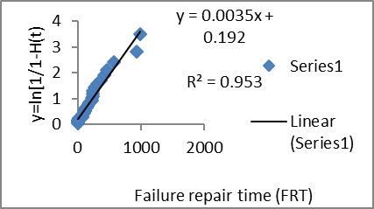
Figure 1: Exponential least-square plot
Example 1 is an example of a ONE-COLUMN figure caption. Please see last page of this document for AN EXAMPLE of a 2-COLUMN Figure.
Figure Labels: Use 12 point Times New Roman for Figure labels. Use words rather than symbols or abbreviations when writing Figure axis labels to avoid confusing the reader. As an example, write the quantity “Magnetization”, or “Magnetization, M”, not just “M”. If including units in the label, present them within parentheses. Do not label axes only with units. In the example, write “Magnetization (A/m)” or “Magnetization {A[m(1)]}”, not just “A/m”. Do not label axes with a ratio of quantities and units. For example, write “Temperature (K)”, not “Temperature/K”.

Footnotes
Use footnotes sparingly (or not at all) and place them at the bottom of the column on the page on which they are referenced. Use Times 10-point type, single-spaced. To help your readers, avoid using footnotes altogether and include necessary peripheral observations in the text (within parentheses, if you prefer, as in this sentence).

Acknowledgment
Put applicable sponsor acknowledgments here; DO NOT place them on the first page of your paper or as a footnote.

References
All publications cited in the text should be presented in a list of references following the text of the manuscript. Reference in the text to literature cited is given by the surname of the author(s) followed by the year of publication, that is, the Harvard Style, e.g. "Smith (1994) has reported ..., which was more recently confirmed (Jackson and Sharp, 1996)."
For references with more than two authors, text citations should be shortened to the first author followed by "et al." However, in the list of References, the names and initials of all authors should be mentioned. Two or more references by the same author published in the same year are differentiated by the letters a, b, c, etc. immediately after the year. The references should be listed in alphabetical order in the list of References, as shown in the following examples:

For Books:
Anderson, J. R., & Bower, G. H. (1973). Human associative memory. Washington, D.C.: Winston.

For Journal Articles:
Ozor, P.A., Nwobodo-Anyadiegwu, E.N., & Mbohwa, C. (2020), Computerised Software Systems in Replacement Maintenance Information Management: A South Africa Experience, South African Journal of Industrial Engineering, Vol 31(3), pp 36-43

Tushman, M. L., & Katz, R. (1980). External communication and project performance: an investigation into the role of gatekeepers. Management Science, 26(11), 1071−1085

For Handbooks, Book Chapters:
Graen, G. B. (2006). To share or not to share leadership: new LMX-MMX network leadership or charismatic leadership on creative projects. In G.B. (Ed.), Sharing network leadership, LMX leadership: The series, Vol. 4. (pp. 25−36). Greenwich, CT: Information Age.

Conference Reports:
Ozor P.A., Njoku, H.O. Ifediora, K.M., Dzar, J. & Mbohwa C. (2019), Condition monitoring with maintenance of dust and soiling induced failures in solar photovoltaic modules installed in NERCD, South East Nigeria, In the proceedings of 7th International Renewable and Sustainable Energy Conference (IRSEC), Agadir, Morocco, pp 1-6

Other Acceptable Sources:
Hannah, S.T. (2006). Agentic Leadership Efficacy: Test of a new construct and model for development and performance. Unpublished doctoral dissertation. University of Nebraska-Lincoln.

Internet Sources:
For Internet sources include the title and full details of the material cited and the URL of the electronic site at which it can be found, as follows:
Neuman, B.C. (1995), "Security, payment, and privacy for network commerce", IEEE Journal on Selected Areas in Communications, Vol. 13 No.8, October, pp.1523-31. Available (IEEE SEPTEMBER) http://www.research.att.com/jsac/ Last Accessed 12th February 2014
If no author can be found, a key word or abbreviation can be used followed by the date when the webmaster last updated the site.

Appendix: Long Mathematical analyses with details, which are subordinate to the main theme of the report or any material similarly classified, should be put into an appendix.

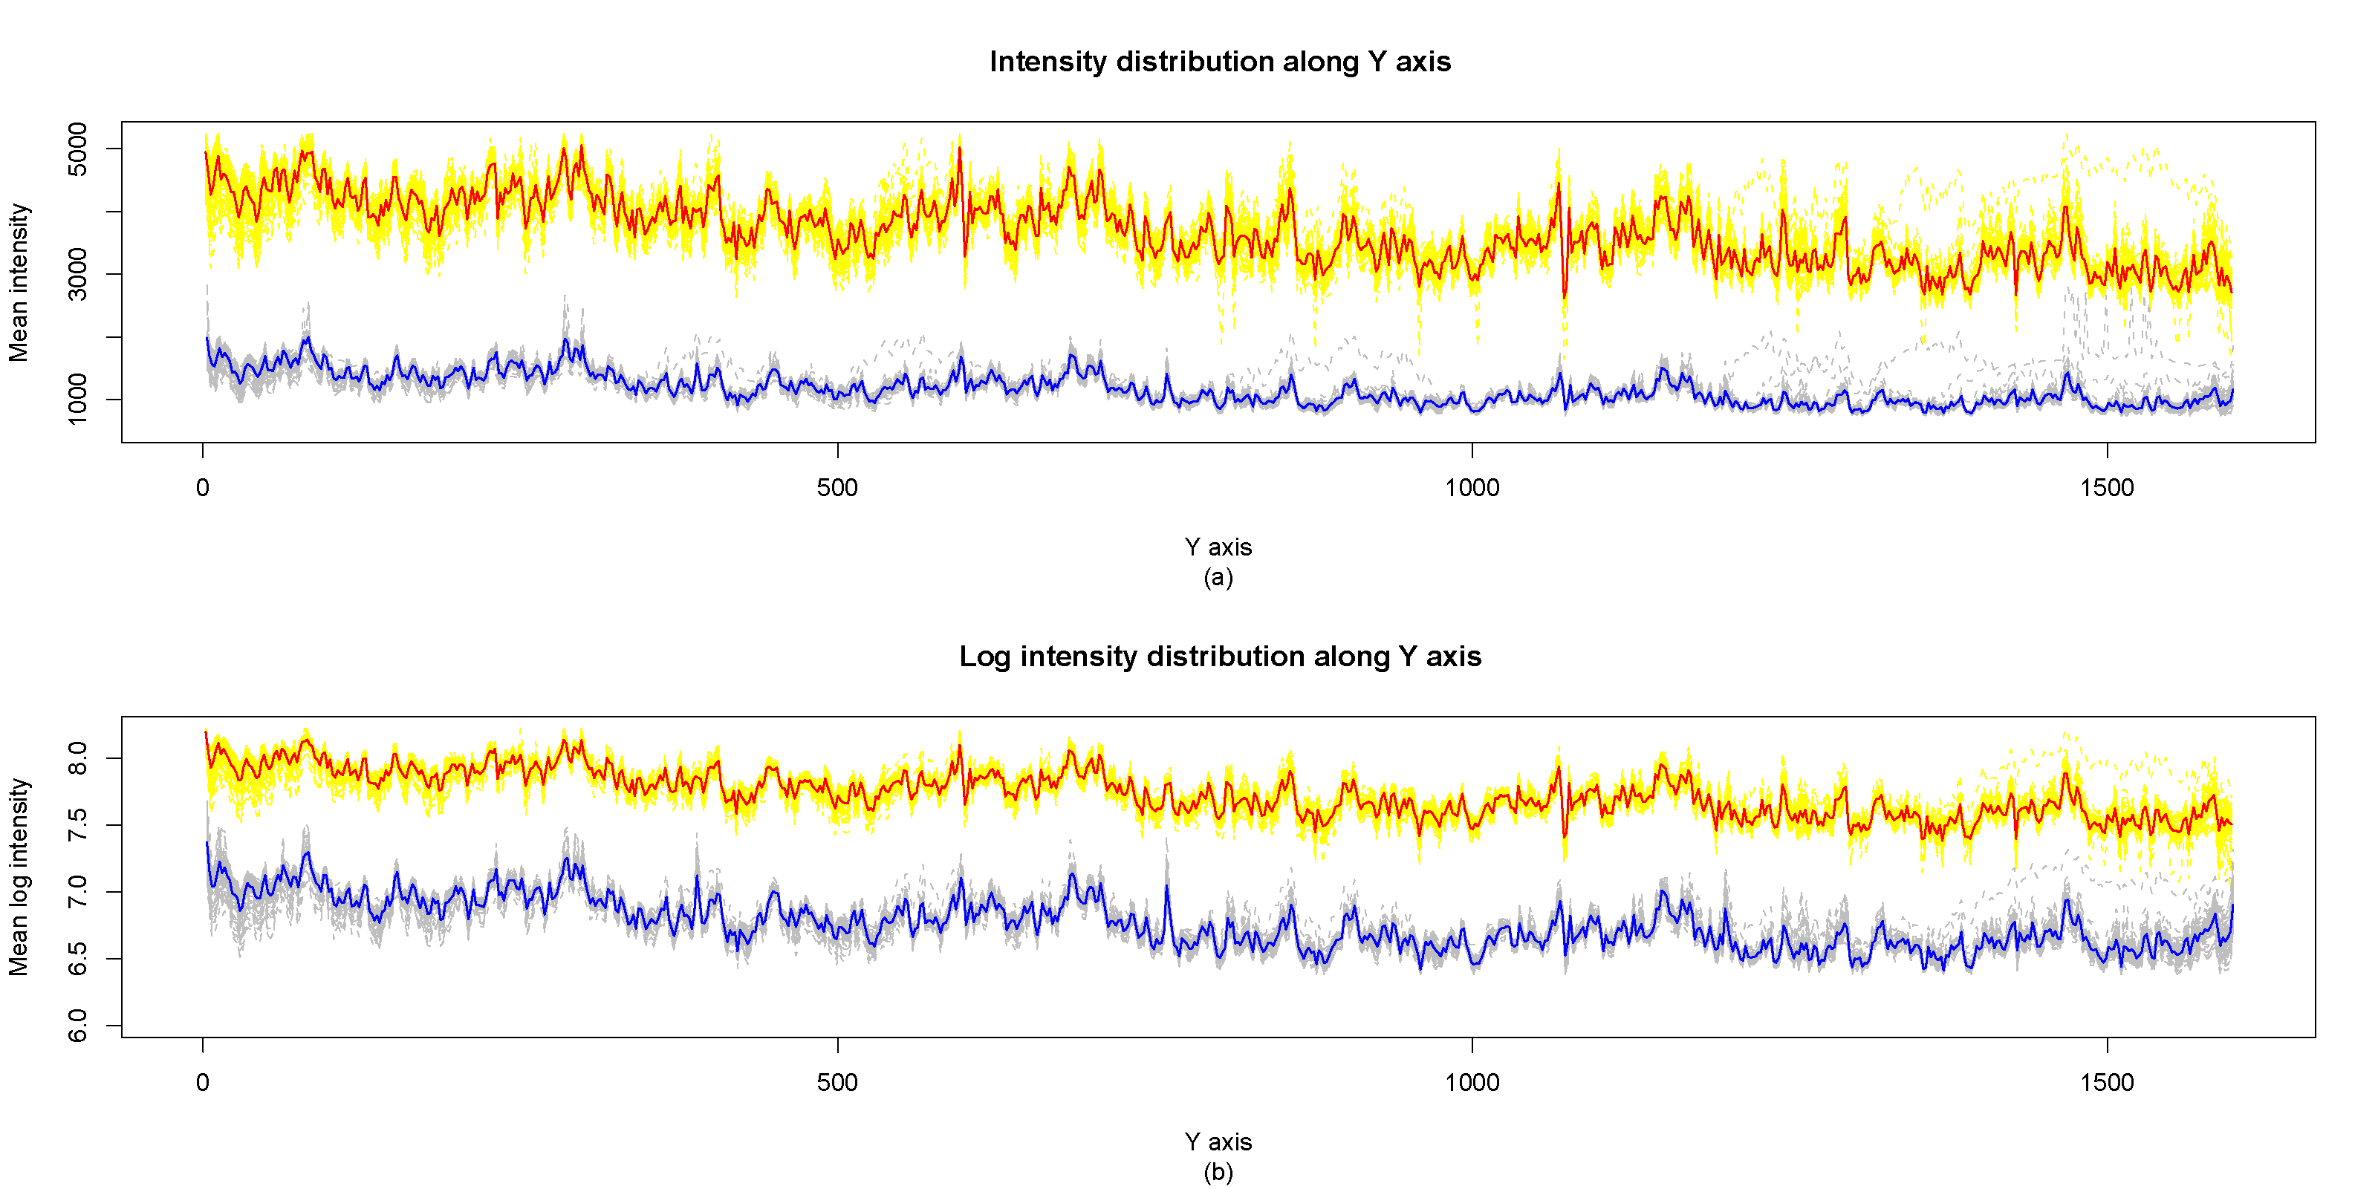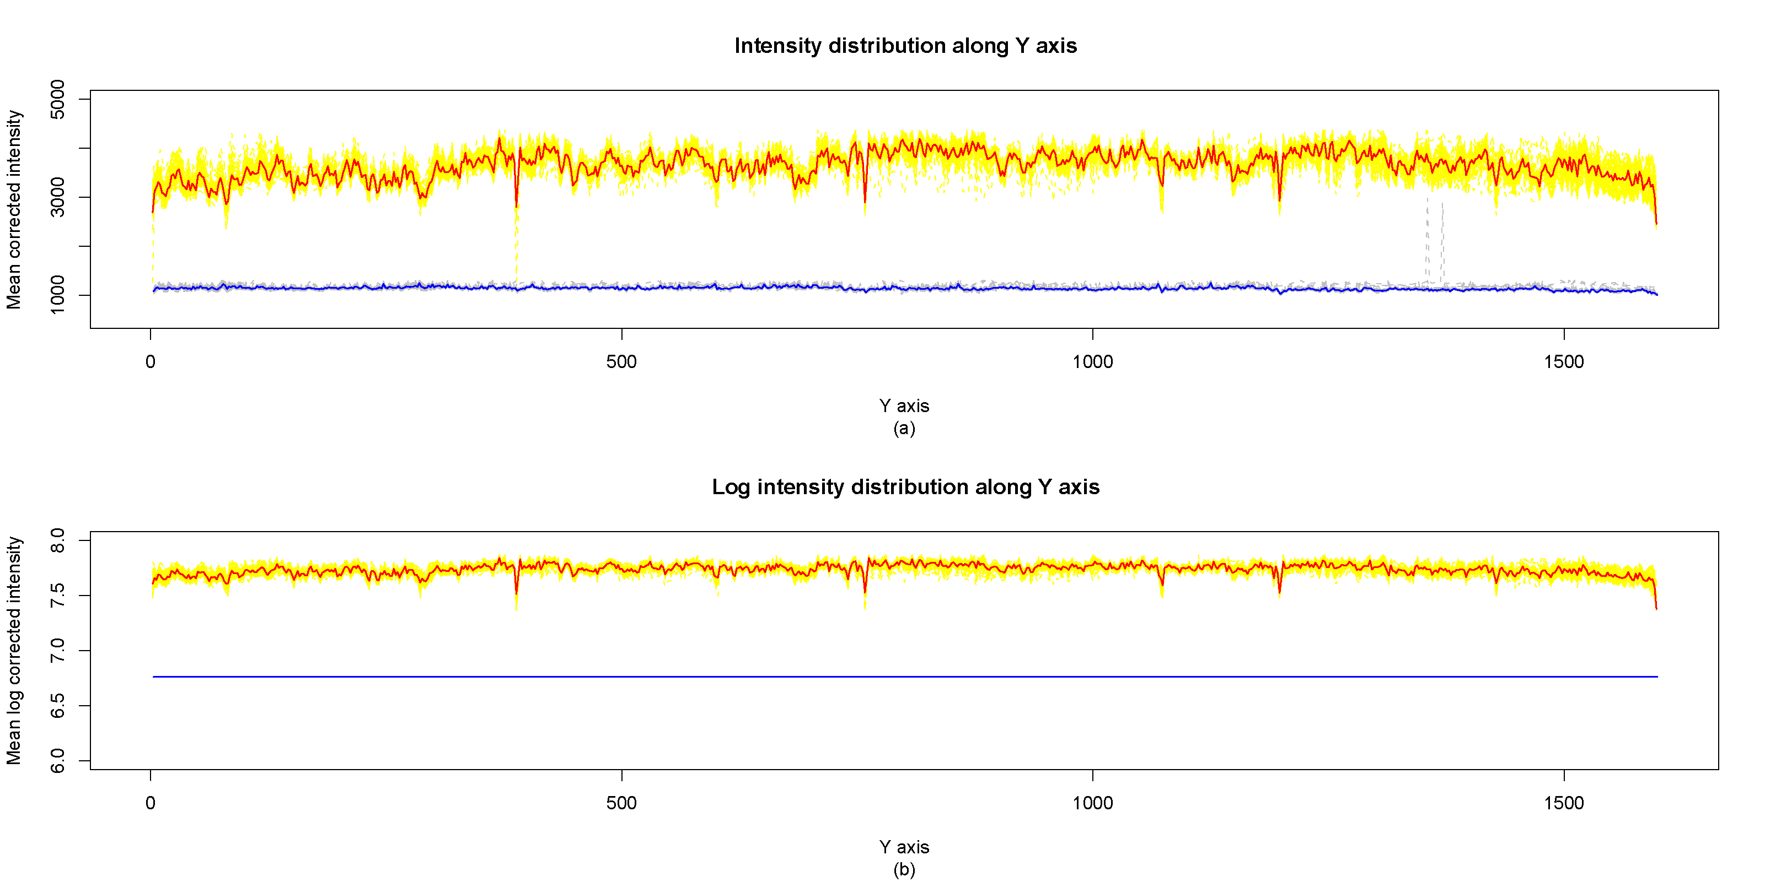
- Example of a TWO-COLUMN figure caption: (a) Blended (b) Unblended
Authors’ background
Your Name | Title* | Research Field | Personal website
Author 1,
Author 2
*This form helps us to understand you and your paper better, the form itself will not be published.
*Title can be chosen from: master student, Phd candidate, graduate assistant, lecturer, senior lecturer, associate professor, full professor
*YOU MAY BE CONTACTED FOR REVIEW OF PAPERS SUBMITTED TO CERTIP 2021 CONFERENCE USING YOUR BACKGROUND. KINDLY ASSIST IN PROVIDING QUALITY REVIEW TO IMPROVE PUBLICATION SPEED AND OVERALL EFFICIENCY OF THE CONFERENCE.

