PROCESS FLOW ON HOW TO REGISTER FOR STAFF ID CARD

- Type in the address bar on your browser www.unn.edu.ng as shown below
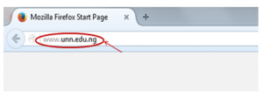
2. Press the enter key on your keyboard, the following screen appear.

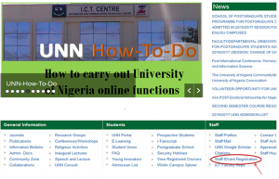
3. Click on the “Staff IDcard registration” under Staff as shown above and the screen below will appear.

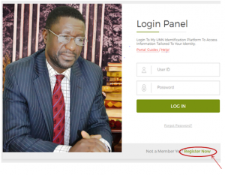
4. Click on “Register Now”, the screen below will appear.

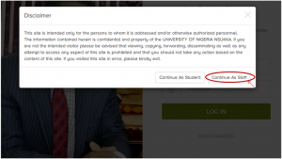

5. Click on “Continue as Staff” as shown above, the screen as shown below will appear.

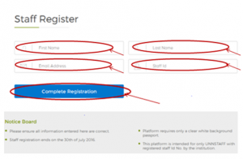
6. Fill in the columns for “First Name”, “Last Name”, Email Address” and “Staff Id”. Then click on “Complete Registration” as shown above. A personalized user name and password will be sent to your email address by noreply, as shown below.

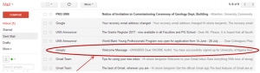

7. Open the mail sent to you by “noreply”, you will see a message that will appear as the one shown below.

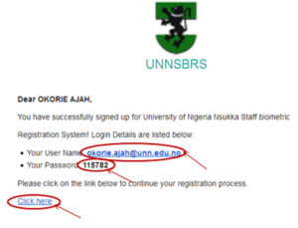
8. Copy the “User Name” and “Password” provided then, click on “Click here” as shown above, this will take you to the login page as shown below.

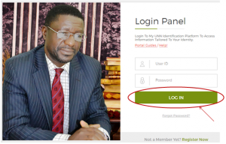
9. Type in the User Name and Password you copied from your E-mail to fill the column for “User ID and Password” respectively. Click on the “LOG IN” button as shown above, and the screen as shown below will appear.

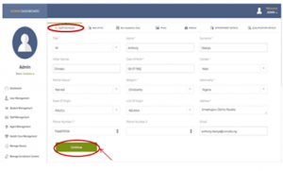
10. This is the “Staff Information”, page. Fill in carefully your “Staff Information” details in the columns provided and click on “Continue” the screen below will appear.

i
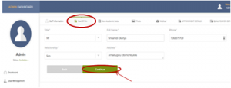11. This is the “Next of Kin”, page. Fill In carefully the details of your “Next of Kin” then, click on “Continue”, the screen will appear as shown below.

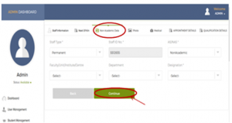

12. This is the “Non-Academic Data”, page. Fill in the details of your “Non-Academic Data” then, click on “Continue”, the following screen below will appear.

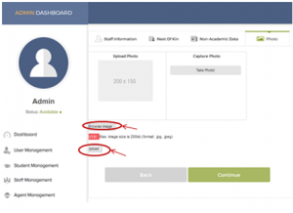13. Upload your passport (a real passport photograph) by clicking on “browse image” to choose the location where the passport image is saved in your computer or any storage device. NOTE: The passport image must fit the size required (200 x 150). Click on “Upload”, the screen as shown below will appear.

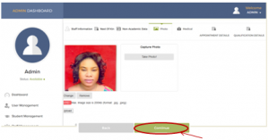14. Click on “Continue” the following screen will appear.

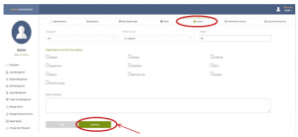15. This is the “Medical”, page. Fill in your details on “Medical”, then click on “Continue”. The screen as shown below will appear.

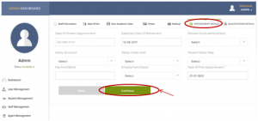
16. This is the “Appointment Details”, page. Fill in your “Appointment Details”, then click on “Continue”, the following screen will appear.

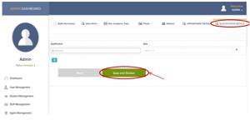17. This is the “Qualification Details”, page. Fill in your “Qualification Details”, then click on “Save and Review”, the following screen will appear.

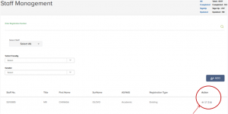

(Below is an enlarged version of the icon circled above. Here, you can view and edit what you have filled.)
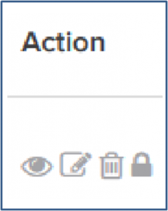

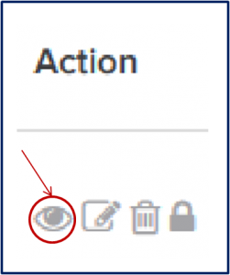
18. Click on the item as shown above to view what you have filled.

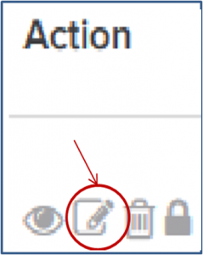
19. Click on the item as shown above to edit what you have filled.
20. when you are done, click on “Save and Review” as shown in 17 above.
19. Go to ICT Access Bank Building, within two months of filling the form to collect your Staff ID card.

