PROCESS FLOW ON HOW TO REPRINT SCHOOL FEES RECEIPT
- Type in the address bar on your browser and type in the portal url (www.unnportal.edu.ng) as shown below.

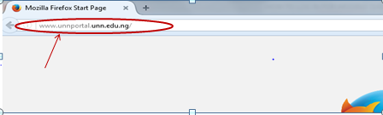

- Press the enter key on your keyboard, the following screen will appear.
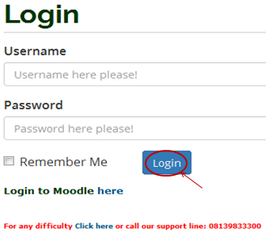
- Type in your registration number as the username, type in your password, then press the enter key or click on the login button to see the following screen

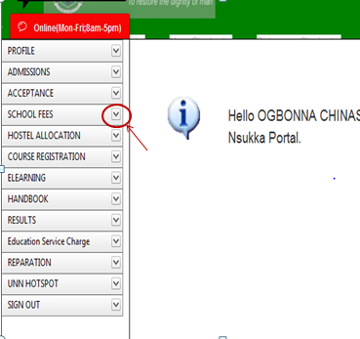
- From the menu items on the left, click on the drop down button on “SCHOOL FEES” as shown above, to see the next screen as shown below. Observe the second dropdown menu under “SCHOOL FEES”
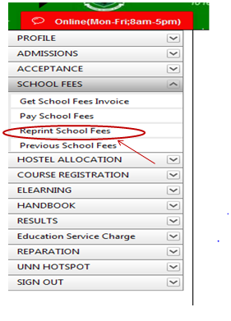
- Click on “Reprint School Fees” and the screen below will appear.

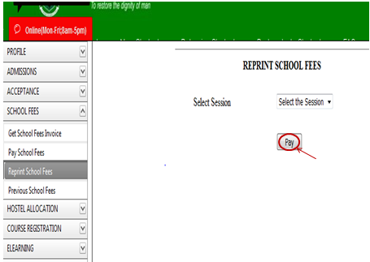

- Click on the “Pay” button after selecting the Session of the school fees you want to print. The fee receipt will appear as shown below.

