PROCESS FLOW OF HOW TO UPDATE PROFILE ACCOUNT ON RESEARCHGATE
- Type in the address bar on your browser www.unn.edu.ng as shown below.
2 . Press the enter key on your keyboard and the following screen will appear.
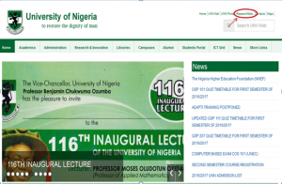
3. Click on “ResearchGate” on the top right side of the page, a screen as shown below will appear.

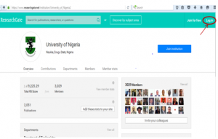
4. Click on “Log in” at the top right side of the screen and the following screen will appears.

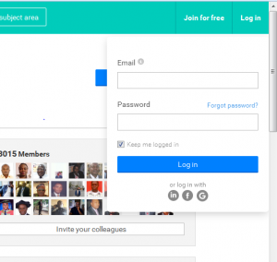5. Type in your UNN e-mail and password, click on “Log in”, the following screen will appear.

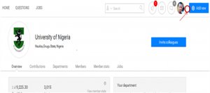
6. Click on the drop down button before “Add new”. Observe the dropdown menu under the button as shown below.

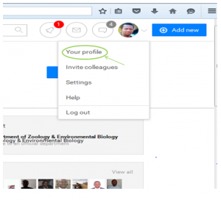
7. Click on ”Your profile”. The screen you see below is part of the screen where you will edit your account.

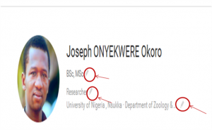
8. Edith your profile following the pencil pointer .

