PROCESS FLOW ON HOW TO OPEN STUDENTS PROFILE
- Type in the address bar on your browser the portal url (www.unnportal.edu.ng) as shown below.

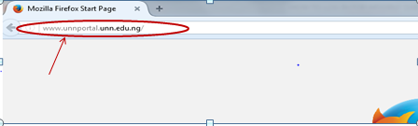

- Press the enter key on your keyboard, the following screen appear.

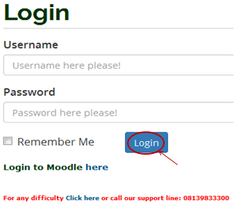
- Type in your registration number as the username, type in your password, then, press the enter key or click on the login button to see the following screen

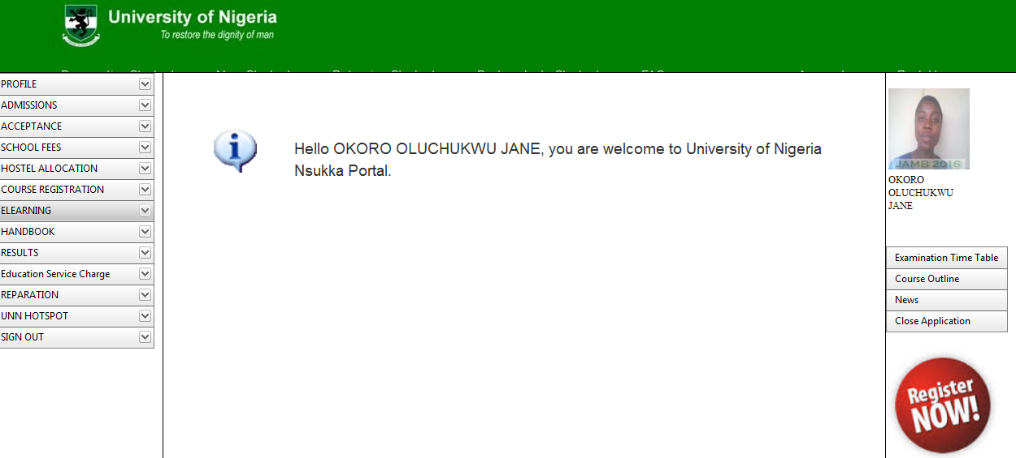

- This is how your profile page looks like.

