PROCESS FLOW ON HOW TO LOGIN FOR MOODLE QUIZ

- Type in the address bar on your browser the portal url (unnportal.unn.edu.ng) as shown below.

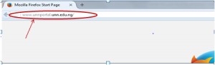
- Press the enter key on your keyboard, the following screen.

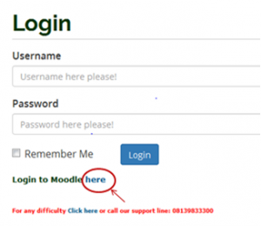
3. Click on “here” as shown above and a screen will appear as shown below.
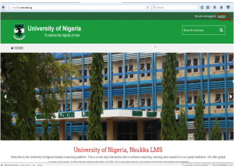

OR

- Type in the address bar on your browser moodle.unn.edu.ng as shown below.

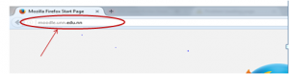

- Press the enter key on your keyboard and the following screen will appear.

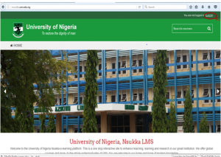
3. Click on “Log in” at the top right corner of the page displayed, the following screen will appear.

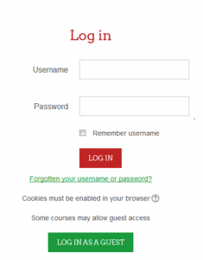
4. Type in your Reg. number (without the forward slash) in the” Username” , type in your password (the one used on the university Portal), then click on the login button to see the following screen .

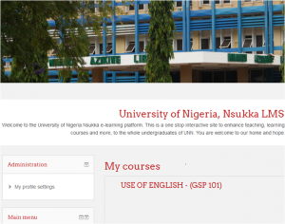

5. Scroll down to ”Course categories”, you will see a section of the a screen as shown below.

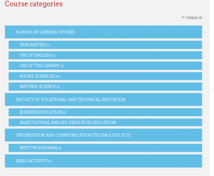
6. Click on the Faculty where the course you want to take the quiz is. For example “SCHOOL OF GENERAL STUDIES” , the following screen will appear.

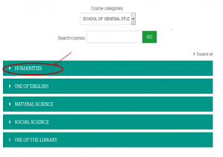7. Click on the Department you want to take quiz. For example “HUMANITIES” as shown above and following screen will appear.

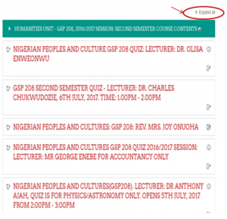9. The Unit opens up and a list of all the courses under the Unit will be displayed. Click on “Expand all“, to see all the list of lecturers and all their courses. The upper part of the screen is as shown below.

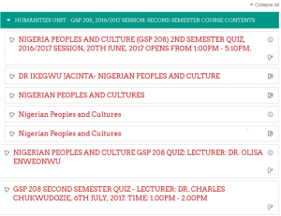
10. Locate the name of the lecturer and the course Title of the quiz you want to take, then Click on it, as shown above. And the screen as shown below will appear.
(Note: The course and the time for the quiz will show. If the time you logged in is not the time for the quiz, you will not be able to take the quiz. If you log in to a lecturer that is not yours, you will not be able to take the quiz.)

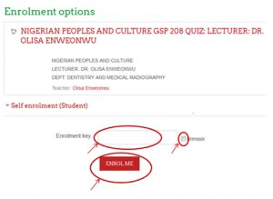
11. Enter the “Enrollment key” given to you by the lecturer.
12. Click on the “Unmask” checkbox to see what you are typing in.
13. Click on “ENROL ME”, then the screen below will appear.

14. Click on “Attempt the Quiz”, to start the quiz.

