PROCESS FLOW FOR NEW STUDENT ORIENTATION UPDATE
Go to UNN website using www.unn.edu.ng and click on UNN portal


Click on New Student Orientation Update
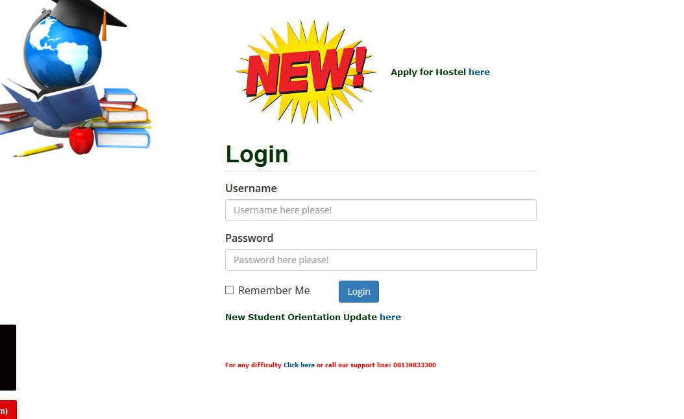

Key in your registration number in the enter username box and click next
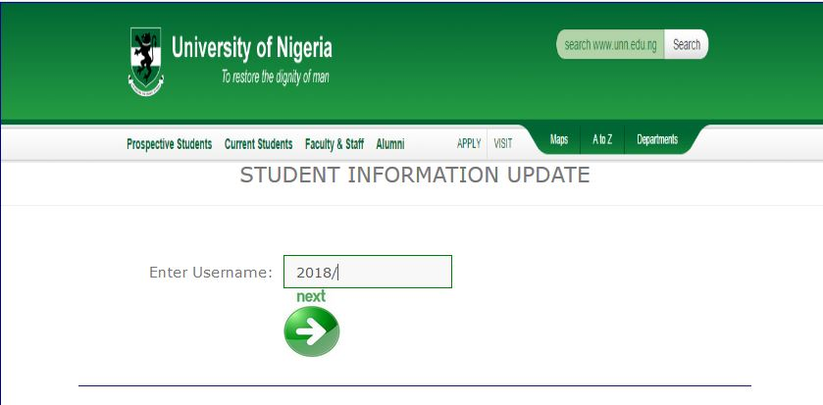
Fill in your mobile number, permanent address, next of kin and next of kin phone number and click next to submit .
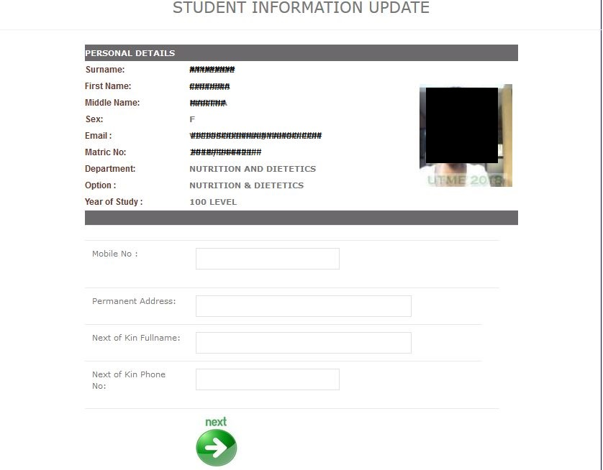
When you submit, the system will acknowledge that you have successfully submitted your update.
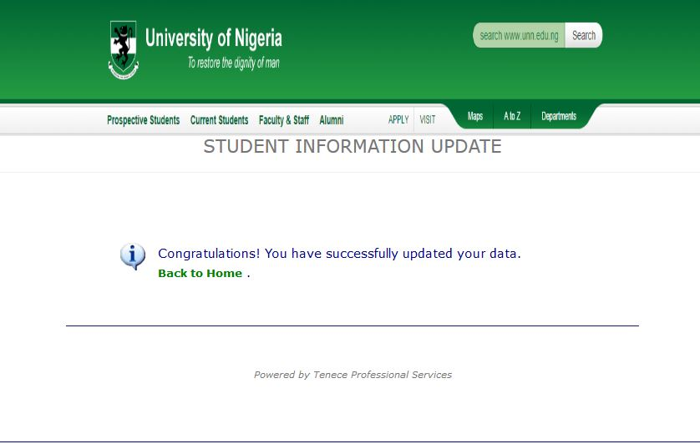

THANKS.

