VC Commissions Video Surveillance Cameras in Campuses
In his effort to strengthen security around the campuses, the Vice-Chancellor, Prof Benjamin Ozumba on Wednesday, May 16, 2018 commissioned surveillance cameras mounted in strategic locations in Nsukka and Enugu campuses of the university.
During the commissioning at Nsukka campus, Prof. Ozumba expressed happiness that the university was moving at a high pace in the use of modern security and communication gadgets.
“This is a modern technology for security and I am happy it is deployed in our university”, the Vice-Chancellor said while addressing a number of university security personnel and ICT engineers who witnessed the commissioning exercise.
The Director of ICT of the university, Dr Olisa Okeke explained that the plan to install the surveillance cameras around the campuses was conceived by the Vice-Chancellor three years ago after his visit to China.
“It was a comprehensive plan to cover the entire university, what we are witnessing today is the Phase 1 of the project”, Dr Okeke said.
The Director described the project as a tremendous investment by the Ozumba’s administration which would enhance the security of lives and properties in the university.
The cameras, according to Dr Okeke are powered by solar energy, with intelligent software for monitoring.
“They are configured with Internet Protocol address which enables us use them with our network”, added Engr Chinemerem Igbokwe the ICT project manager for the job.
Chidubem explained that the cameras could store recorded images for a period of up to three months and the storage capacity could also be increased if need be.
Eight security personnel, according to Engr Igbokwe had been trained on how to use the cameras.
In his response, the acting Chief Security Officer of the university, Sir, R.C. Nwafor thanked the Vice-Chancellor for boosting the performance of the security department with the deployment of the cameras.
“We cannot overemphasis our heartfelt joy over your unflinching attention and benevolence to the Security Department since your assumption of office in June 2014”, Nwafor said while commending the Vice-Chancellor for lifting the ban on the promotion of staff in the security unit.
The Deputy Vice-Chancellor, Administration, Prof Charles Igwe also witnessed the commissioning exercise which was anchored by the Public Relations Officer, Chief (Dr) Okwun Omeaku.
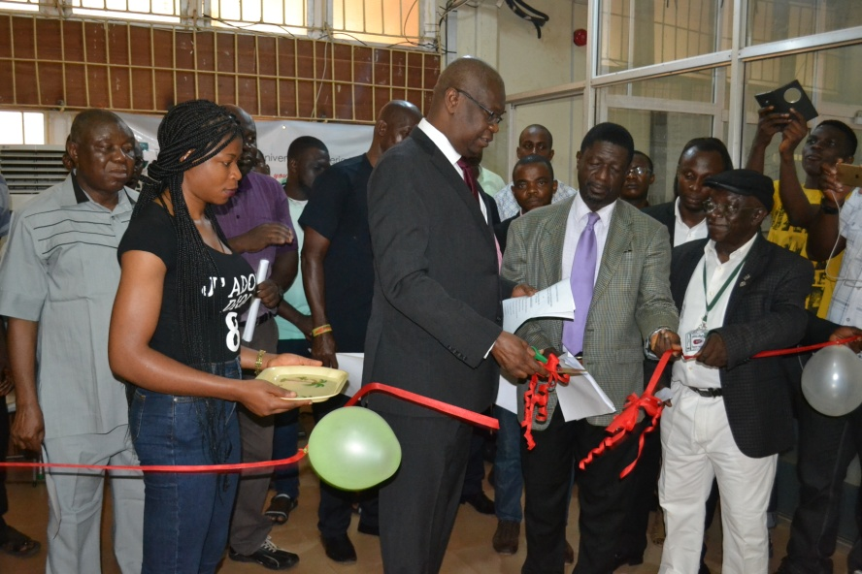
The Vice-Chancellor, Prof Benjamin Ozumba Commissioning the surveillance cameras at Nsukka campus.

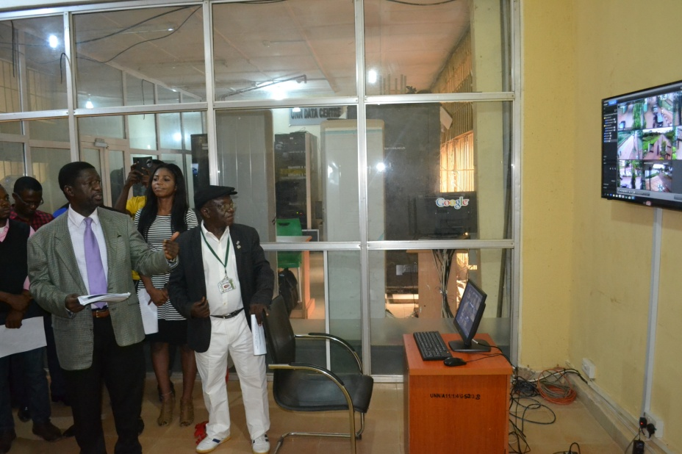
Dr Olisa Okeke, ICT Director (left) and Chief (Dr) Okwun Omeaku, Public Relations Officer at the Commissioning.

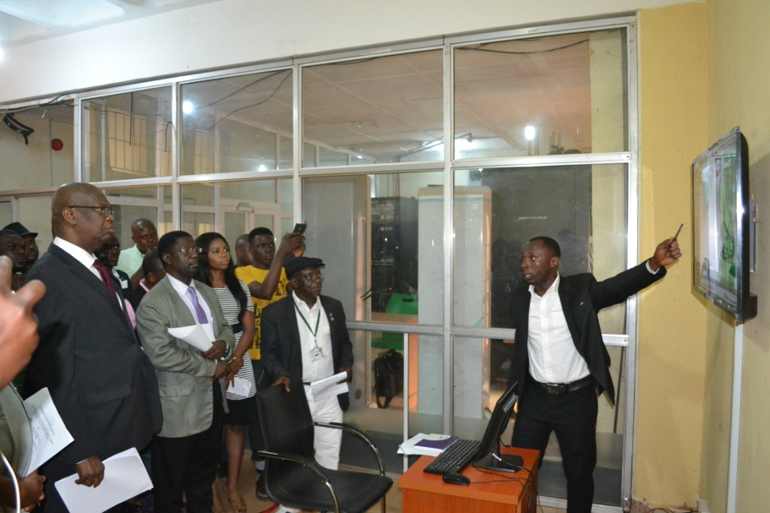
Engr Chinemerem Igbokwe, project coordinator, demonstrating the operations of the surveillance camera to the Vice-Chancellor.
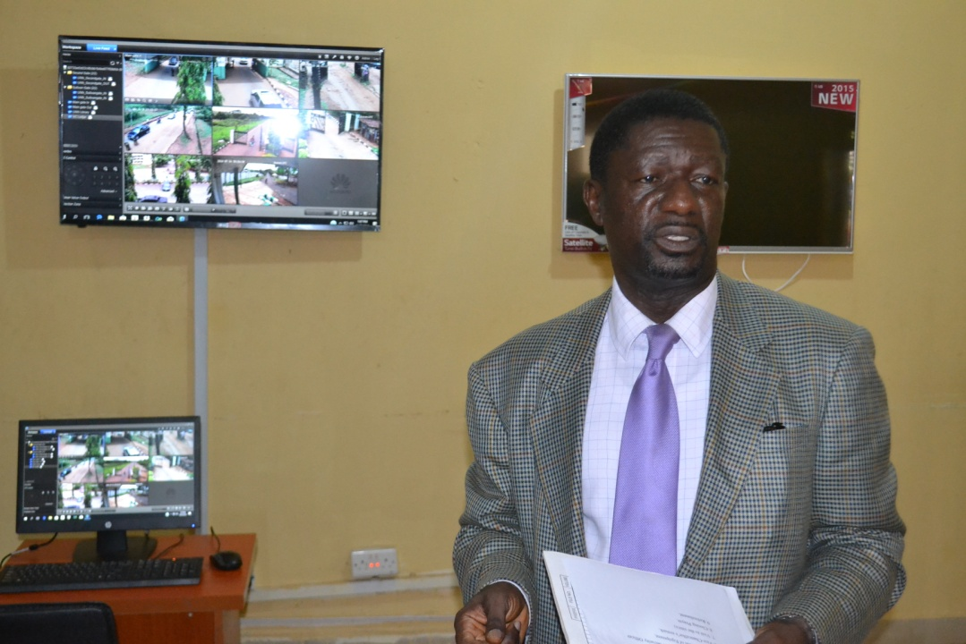
Dr Olisa Okeke at the Control station of the surveillance camera

