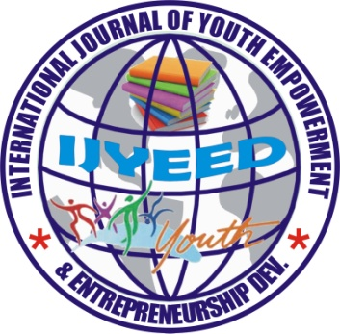

INTERNATIONAL JOURNAL OF YOUTH EMPOWERMENT
AND ENTREPRENEURSHIP DEVELOPMENT (IJYEED-JOURNAL)
ISSN: 2449-0342 - Volume 2, Number 1, Deadline: June 30, 2018
CALL FOR PAPERS

International Journal of Youth Empowerment and Entrepreneurship Development (IJYEED-JOURNAL) is an International peer-reviewed Journal. It is an open access journal that provides rapid bi-annual publication of well edited papers from academic lecturers, global youths, scholars, researchers, students and other experts with papers that contain their original works in English only but limited to the following areas of research which will be considered for publication in our next issue (Volume 2, Number 1): Peace-building and security, Youth Empowerment, Women Empowerment, Entrepreneurship Development, Gender Issues, Community Development, Humanities, Skill Acquisitions, Alcohol Prevention, Drug Abuses, Cultural Diversity, HIV/AIDS, ICT, NGOs and other Youth related issues etc. IJYEED-JOURNAL welcomes the submission of manuscripts that meet the general criteria of significance excellence. Papers will be published approximately three months after submission upon Notification of Acceptance by the Editorial Team. Papers submitted must be with the understanding that they have not been published elsewhere and are not currently under consideration by any other publisher. The paper should meet the requirements of IJYEED Journal.
The corresponding author is responsible for ensuring that the article's publication has been approved by all the co-authors (if any). Further correspondence and proofs will be sent to the corresponding author before publication unless otherwise indicated. Currently, we are seeking research/review articles, short notes and case studies for our Volume 2; Number 1, 2018 issue with an editorial focus on topics and research of current global demands. The Article submission deadline is June 11, 2018 to be considered for the August, 2018 publication.
Authors are requested to submit their articles online to: paper.ijyeedjournal@gmail.com, paper.ijyeedjournal@unn.edu.ng and two copies of manuscripts to the Managing Editor. Manuscripts should be prepared and submitted on MS-Word font size 12, Times New Romans and double Line spacing, Authors should strictly conform to APA 6th edition referencing style.
Each paper should have an abstract of about 250 words. Manuscripts should not exceed 15 pages including the references. Authors are required to make a payment of two five thousand naira (₦25,000.00) processing fee and publication after which the paper has been accepted for publication via First Bank Plc, Account Name: IJYEED Journal, Account Number: 2023694895. A final decision on every manuscript will be communicated to the corresponding author with reviewer’s comments. All accepted manuscripts will be published within the last week of August, 2018. We look forward to counting you as one of our distinguished authors. Thanks!

For further enquiries, please contact:

NWEKE PRINCE ONYEMAECHI
Managing Editor (IJYEED-JOURNAL)
Department of Educational Foundations
University of Nigeria, Nsukka
Enugu State – Nigeria
Tel: +234 (0) 8185706536, +234 (0) 7054258185
nweke.prince@blogspot.com
Email: paper.ijyeedjournal@gmail.com, paper.ijyeedjournal@unn.edu.ng
nweke.prince@unn.edun.ng

PUBLICATION FEE:
Foreign Authors: $70 USD - Nigerian Authors: #25,000

Note: Only manuscript sent to this email will be consider for publication: ijyeedjournal@gmail.com

