PROCESS FLOW ON HOW TO LOGIN FOR CBT EXAM
- Students are admitted to the exam venue using their university identification card.
- Login using your registration number as the user name and password E.g 2016/234567.

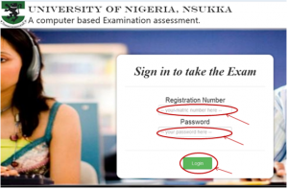

- Click on login to access your questions.
NB
- Only student that have duly registered for the course online would be allowed to gain access to the examination questions.
- Ensure you type your registration number correctly including the slash else a message would pop up “The Application number is not found in the database”, as shown below.

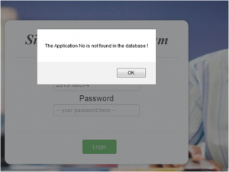

- Ensure you come into the exam with your batch else this message would pop up “Please you do not have course to write now” as shown below.

