PROCESS FLOW ON HOW TO GENERATE INVOICE FOR CERTIFICATE COLLECTION

- Type in the address bar on your browser unnportal.unn.edu.ng as shown below.

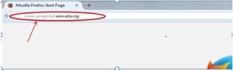
- Press the enter key on your keyboard, the following screen will appear.

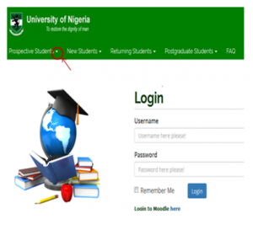
- Click on the drop down button on “Prospective Student”, observe the drop down menu as shown in the screen below.
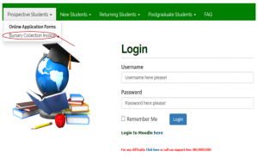
- Click on “Bursary Collection Invoice”, the following screen will appear.

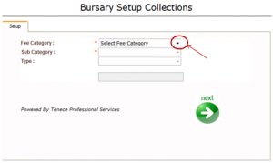
- Click on the drop down button on “Select Fee Category”, observe the drop down list under “Select Fee Category, then select “Student related Payment” the screen as shown below will appear.

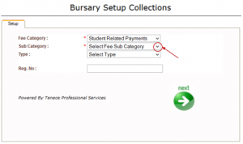
- Click on the drop down button on “Select Fee Sub Category” observe the drop down list under “Select Fee Sub Category”, select “Certificate Collection” the following screen will appear.

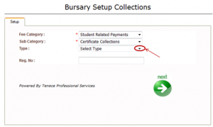
- Click on the drop down button on “Select Type” observe the drop down menu, then, select “Undergraduate” ( for undergraduates), the screen as shown below will appear.

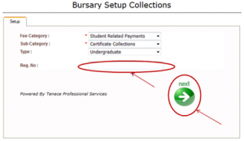
- Type in your registration number in the “Reg. No: column, click on “Next” button as shown above, then, the following screen will appear.

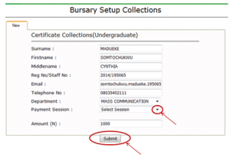
- Click on the drop down menu on “Select Session” to select the session you want to pay for.
- Click “Submit” as shown above. The invoice will be generated as shown below.

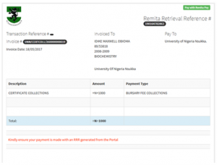
- Print out the invoice.
- Proceed to the recommended bank with the invoice to make payment.
- The bank will give you a bank conformation slip for the invoice generated .

