PROCESS FLOW ON HOW TO ADD/DROP COURSES
This can only be done by students before their courses are approved. After approval, follow the procedures below:

- Type in the address bar on your browser (unnportal.unn.edu.ng) as shown below.

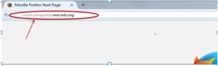
- Press the enter key on your keyboard to see the screen below.


- Click on the drop down button on “Prospective Student”, observe the drop down menu, as shown in the screen below.

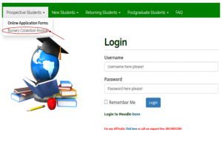
- Click on “Bursary Collection Invoice”, the following screen will appear.

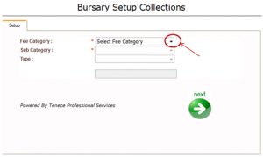
- Click on the drop down button on “Select Fee Category”, observe the drop down list, then select “Student Related Payment” the screen as shown below will appear.

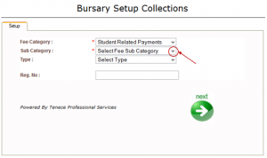
- Click on the drop down button on “Select Fee Sub Category” as shown above, observe the drop down menu, then select “Add / Drop Form” the following screen will appear.

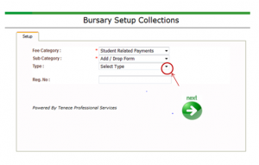
- Click on the drop down button on “Select Type” as shown above, observe the drop down menu, then, select “Undergraduate” ( for undergraduates), to see the screen below.

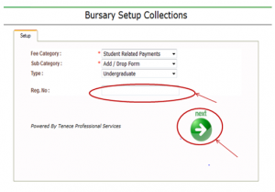
- Type in your registration number in the “Reg. No:” column, then click on “next” button and the following screen will appear.

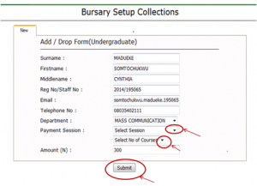
- Click on the drop down button on “Payment Session” to select the session you want to pay for.
- Click on the drop down button on “Select No. of Courses” to select the number of courses you want to register
- Click on the “Submit” , then the invoice will appear as shown below.

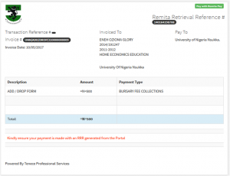

- Print out the invoice.
- Proceed to the recommended bank with the invoice to make payment.
- The bank will give you a bank conformation slip.
- Go to cash office with the conformation slip from the bank.
- At cash office, the slip would be convert to receipt.
- Go to the admission unit for collection of Add/Drop card with the receipt.
- Send an e-mail with your University e-mail address to the Head of Department through the course adviser, to the admission office with the attachment of the scanned copy of the Add/Drop card after it must have been duly signed by the appropriate authorities (Head of Department, Academic Adviser, the Dean of Faculty, Registrar’s representative to the Faculty)
- The Admission office forwards your request to the Registrar.
- The Registrar approves and minutes it to the Director ICT for implementation
- The Director ICT minutes it to the appropriate unit for implementation.

