PROCESS FLOW ON HOW TO ACCESS THE MIIT COURSE ONLINE
- Type in the address bar on your browser www.unn.edu.ng as shown below.

2. Then press the enter key on your keyboard, the following screen will appear.

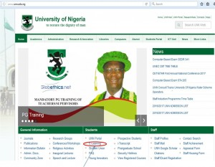
3. Click on “E-Learning, as shown above, the following screen will appear.
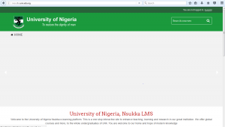
4. Scroll down to see a section of the screen that appears as below.
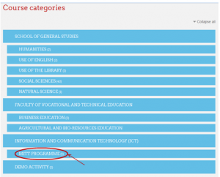
5. Click on “MITT PROGRAMME” as shown above to see the next screen

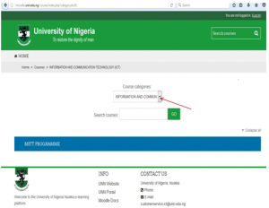
6.Click on drop down button, and select “ICT/MITT PROGRAMME” which will appear as below
7. Next step requires logging in as a student which requires student’s details.

