PROCESS FLOW ON HOW TO ACCESS LECTURER’S MATERIALS FROM THE MOODLE PLATFORM
- Type in the address bar on your browser unn.edu.ng as shown below.
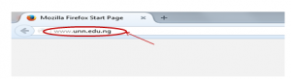
- Press the enter key on your keyboard, the following screen will appear.

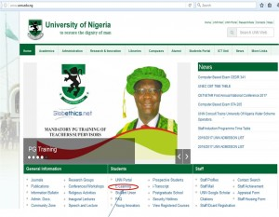
- Click on “E-Learning” , as shown above, the following screen will appear.
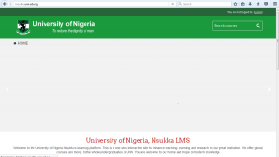

4. The top enlarged version of the screen above is as shown below.
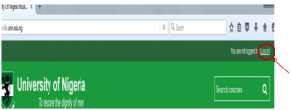

5. Click on “Log in” at the top right corner of the page displayed, the following screen will appear.

6. Type in your matriculation number( without the forward slash) as the “Username”, type in your password, the one used on the university Portal), then click on the login button to see the following screen.

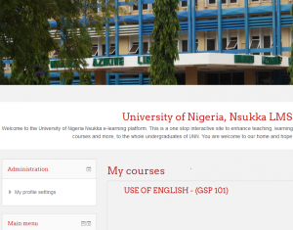
7. Scroll down to Course categories , you will see a section of the a screen as shown below.
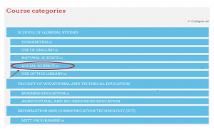

8. Click on the GSP course you want to get the lecturer’s materials. For example “SOCIAL SCIENCES (2)” and the screen below will appear.

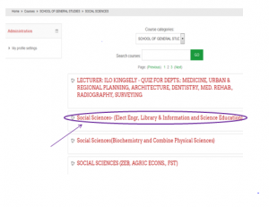9. Click on the course you want to get the lecturer’s materials. For example “Social Sciences- (Elect Engr, Library & Information and Science Education)” the following screen will appear.

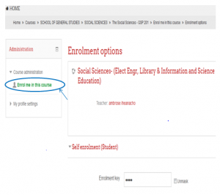
10. Click on “Enroll me in this course”, then, the course materials will appear and you will be able to download or read the materials.

