PROCESS FLOW ON HOW TO GENERATE ACCEPTANCE FEES INVOICE

- Type in the address bar on your browser (unnportal.unn.edu.ng) as shown below.
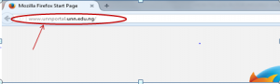
Press the enter key on your keyboard, the following screen will appear.
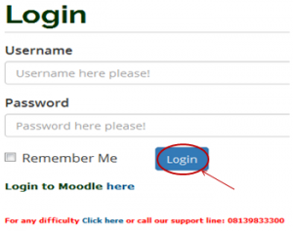
3. Type in your registration number as the username, then type in your password. Press the enter key or click on the login button to see the following screen.

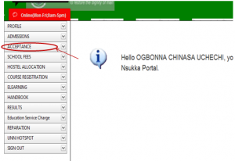
4. From the menu items on the left, click on “ACCEPTANCE” to see the next screen as shown below. Observe the dropdown menu under “ACCEPTANCE”

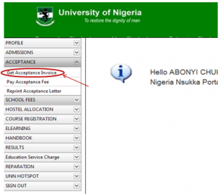
5. Click on “Get Acceptance Invoice”. You will notice a dialog box as in screen below (Read through this procedure carefully to understand the due process of paying your acceptance fees).

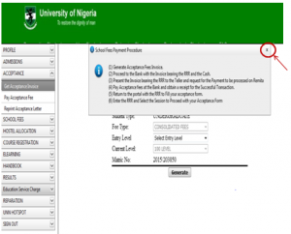6. After reading the procedure, close the dialog box, by clicking on the “x” mark at the right hand side of the dialog box to enable you see the main screen , which will appear as follows:

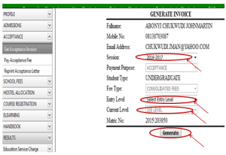
7. Click on the drop down key on “Select Session” to select the session of the invoice you want to generate
8.Click on the drop down key on “Select Entry Level” to select entry level
9.Click on the drop down key on “Current Level” to select the level you are in
10.Click on “Generate” button. The invoice will appear as shown below.

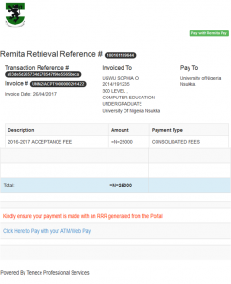
11. Print the Invoice, then follow the “school Fees Payment Procedure”, to pay your Acceptance fees in the bank.

