PROCESS FLOW ON HOW TO CONNECT LAPTOP TO LIONET WIRELESS NETWORK
Note: Your laptop must be connected to a Lionet radio, example Lionet@ ICT before you will be able to connect to Lionet Wireless network.
- Type in the address bar on your browser www.unn.edu.ng as shown below.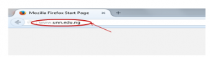
- Press the enter key on your keyboard, the following screen will appear
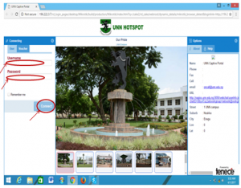
3. Type in the Lionet “Username” and “Password" sent to you by oncall@unn.edu.ng, on the screen above and click on connect, the screen will appear as shown below.

4. You can now go ahead to do whatever you wish to do on the internet.

