PROCESS FLOW POSTGRADUATE WORSHOP/LIBRARY TRAINING
- Go to unnportal.unn.edu.ng
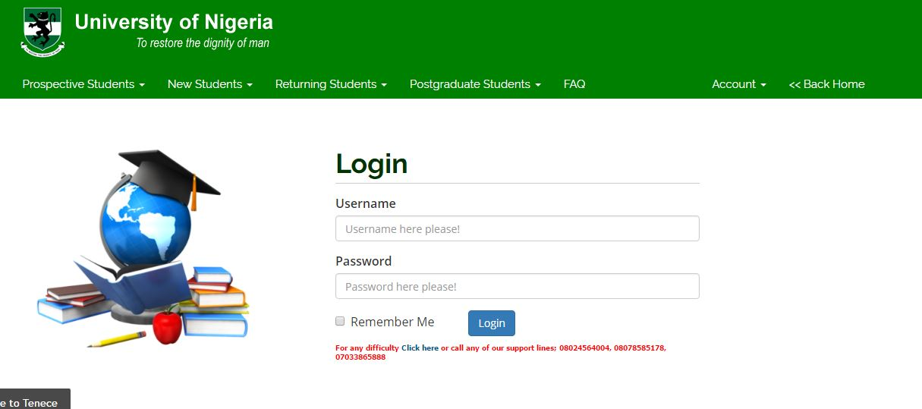

- Click on postgraduate students
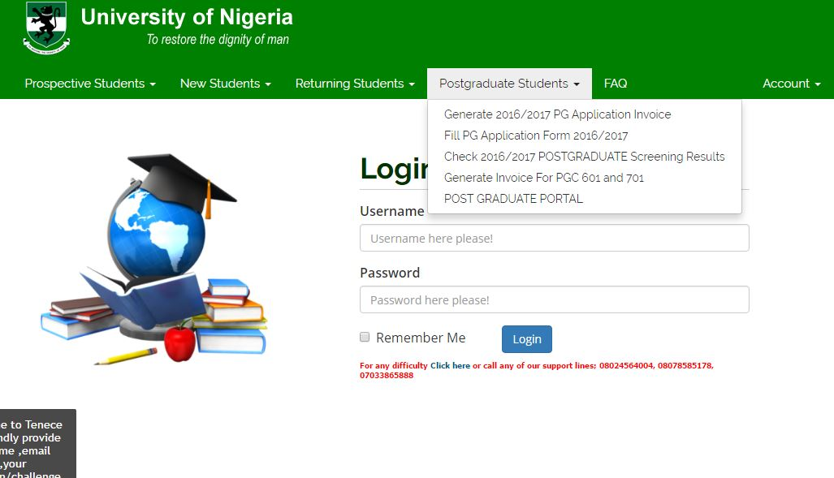
- Click on generate invoice for PGC 601 and 701
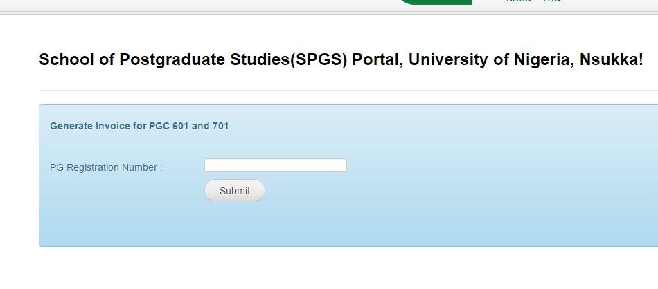
- Enter your registration number and click submit
- Go to any of the banks with the invoice and make your payment.(i.e there is also provision to make payment with your ATM)

