SCREENING APPLICATION FORM PROCESS FLOW
- Check if your name is on the list by clicking on Admission list under students in the UNN website- www.unn.edu.ng
- Type www.unn.edu.ng at the browser tab, the page below preloads.
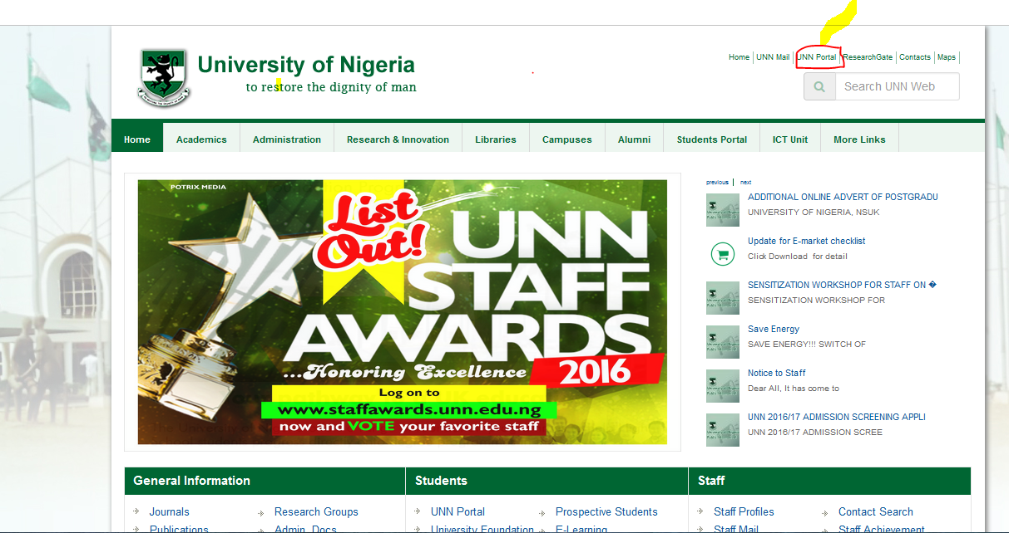

- Click on UNN Portal link and the page below loads.

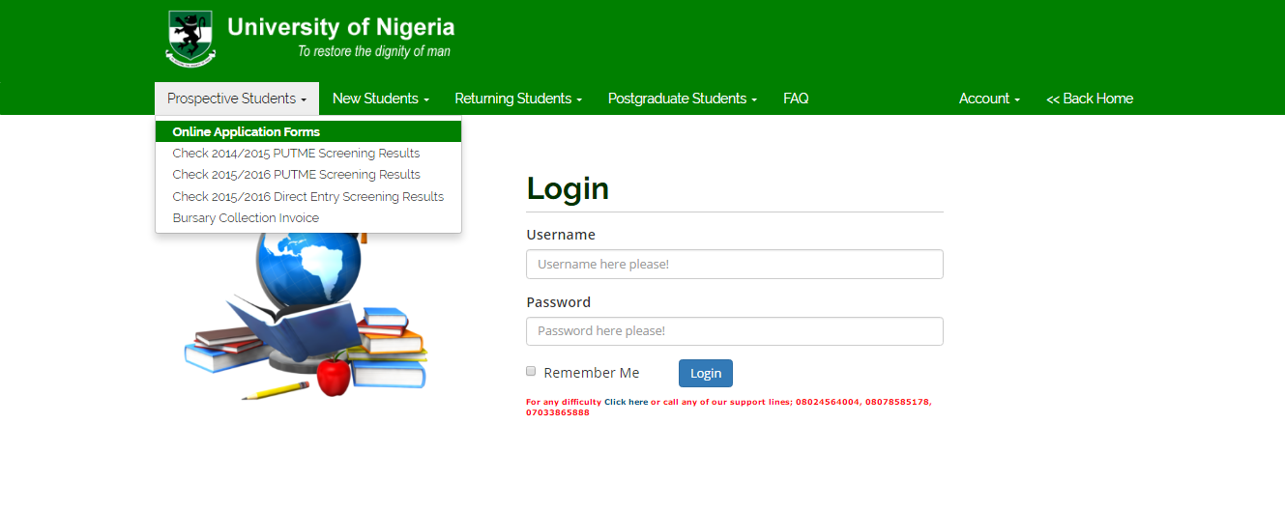

- Click on Prospective Students menu and select Online Application Forms, the page below appears.

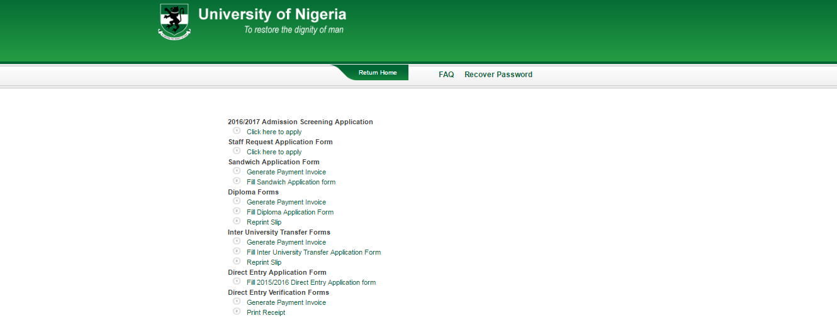

- Click on Click Here to Apply link under 2016/2017 Admission Screening Application menu, the page below appears.

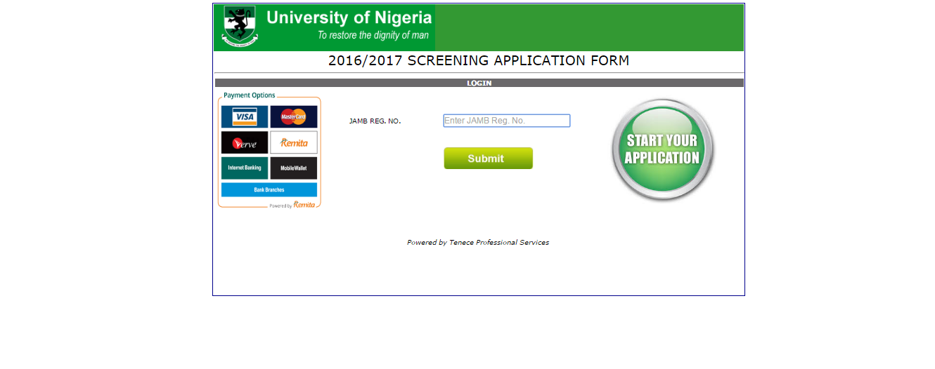

- Type in the JAMB Registration Number and Click the Submit button, the page below appears.

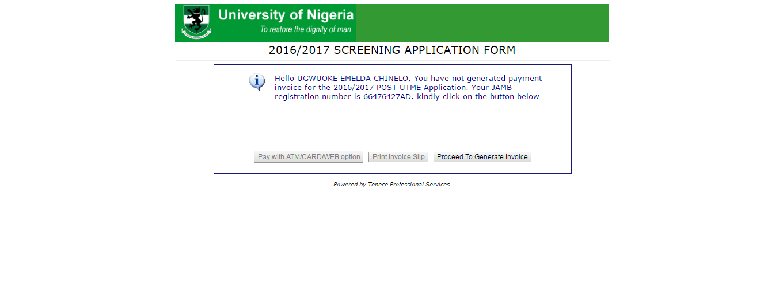

- Click on Proceed to Generate Invoice button, the page below appears, Complete the form and Click the Submit button.

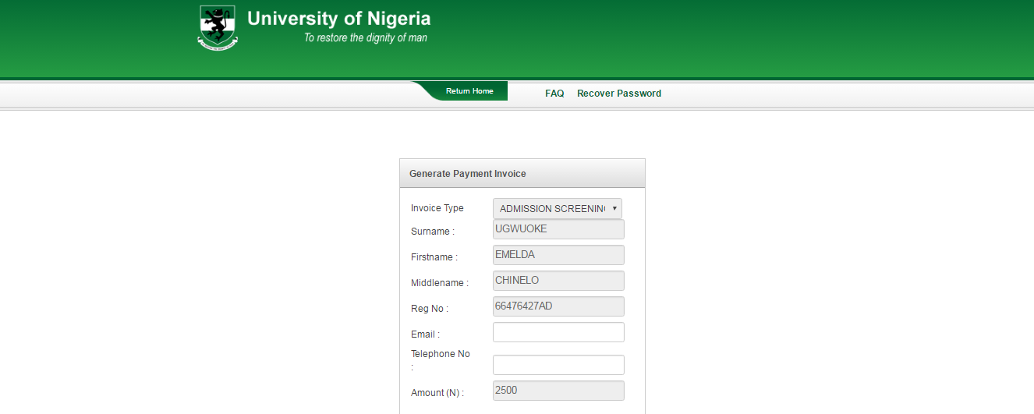

- The page below appears showing the Payment invoice slip for printing and payment at the bank

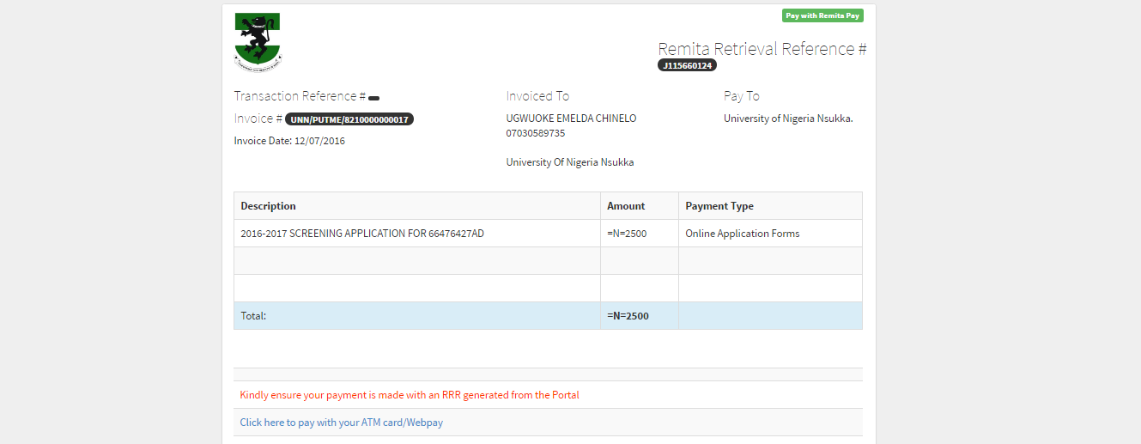
- Click on Prospective Students menu and select Online Application Forms, the page below appears.

- Click on Click Here to Apply link under 2016/2017 Admission Screening Application menu, the page below appears.

- Type in the JAMB Registration Number and click the Submit button, the page below appears.

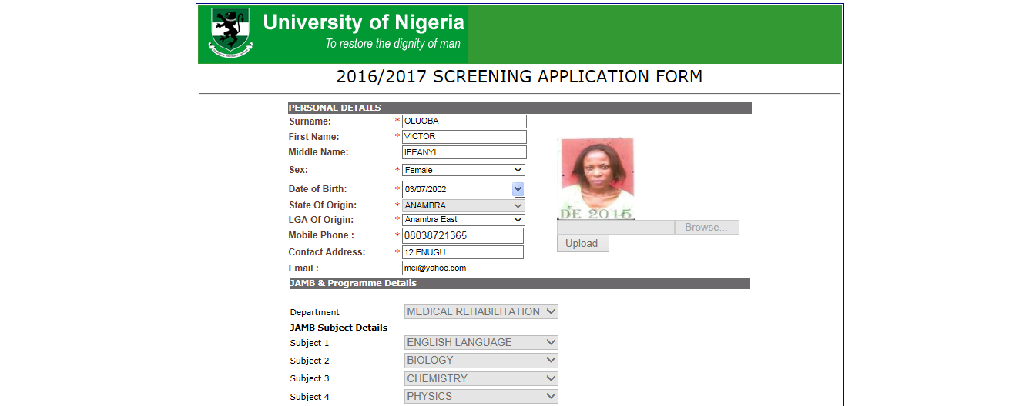
- Complete the Form and Click Next button, the page below appears.

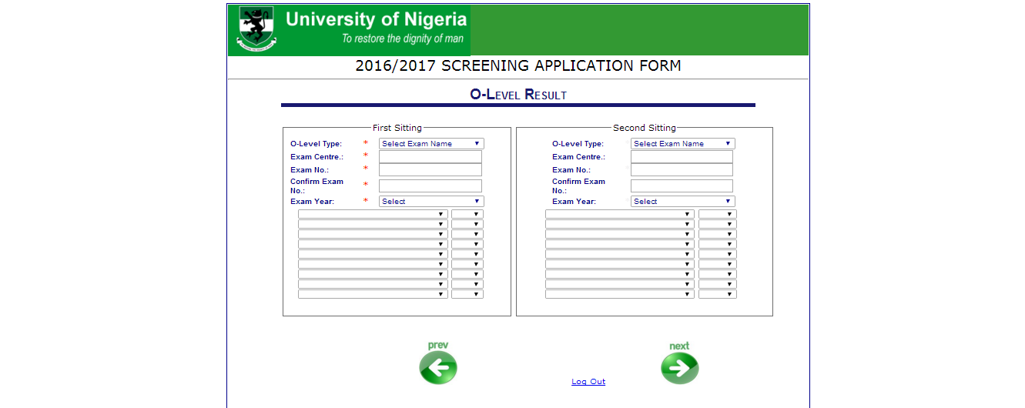

- Complete the form, Select the Subject and the Grades then Click Next button, the page below appears.

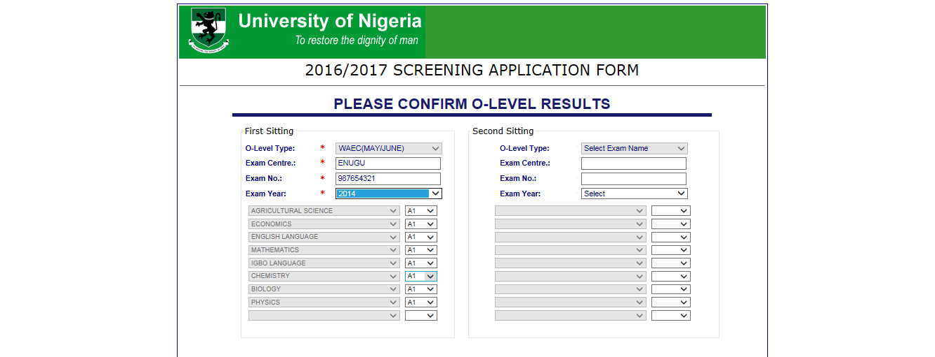

- Reselect the Required Fields and Click the Next button, the page below appears.

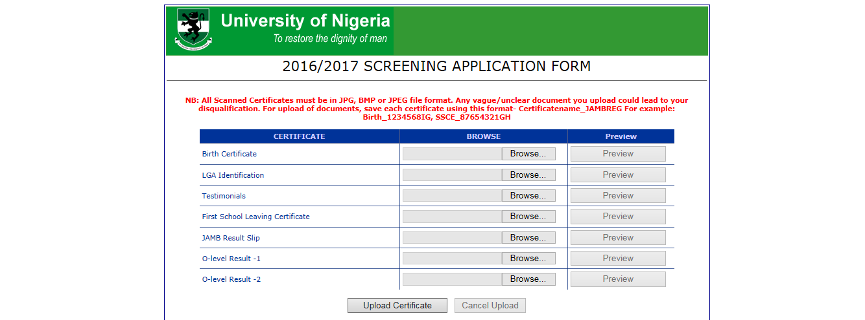
- Click the Browse button to Browse for the Scanned Documents then Click the Upload Certificate Button, the page below appears showing a successful upload, Click the Next button.

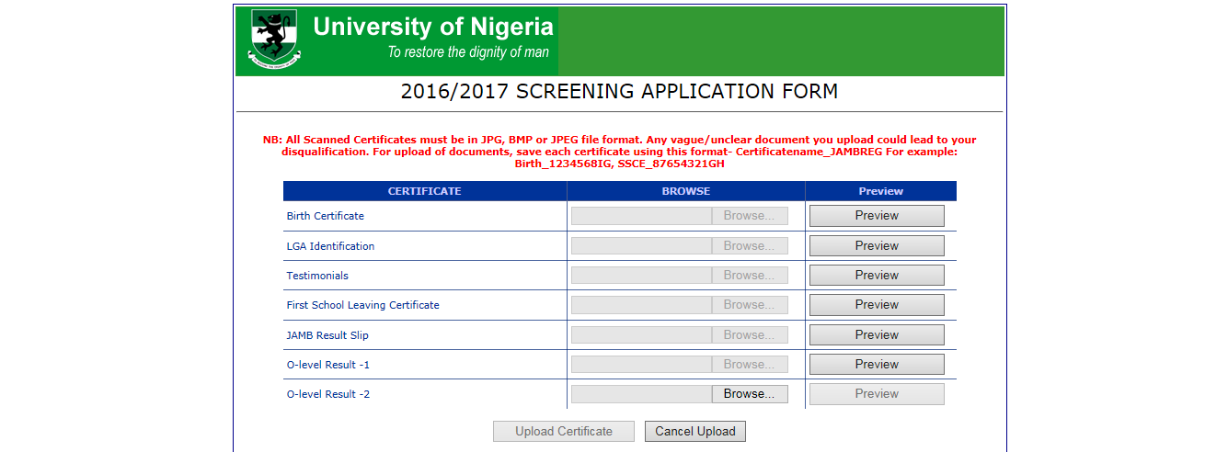

- The page below appears showing the Completed Form for Confirmation, Select the Checkbox then Click the Submit button.

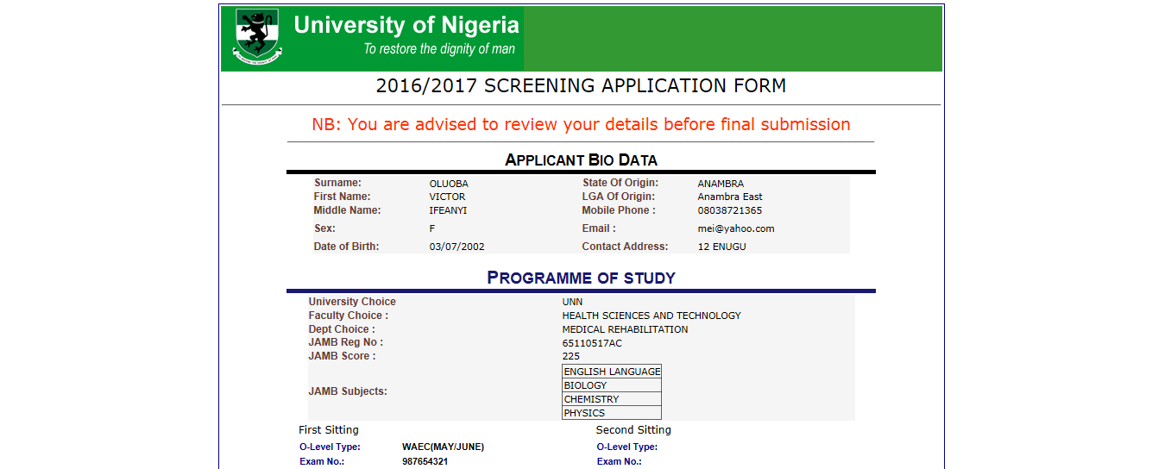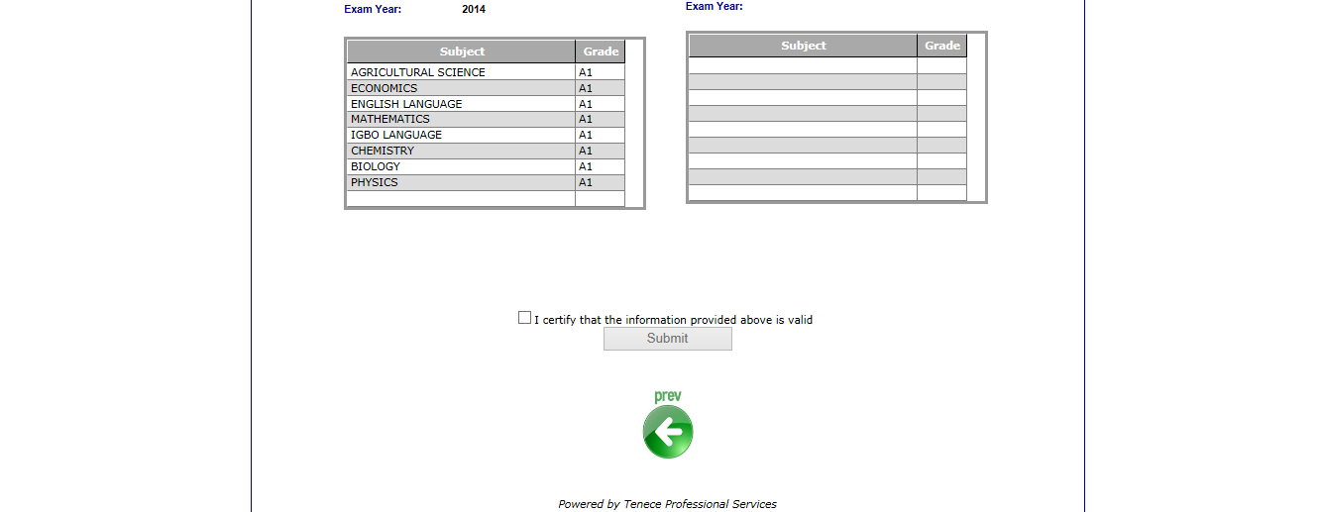

- The page below appears showing the Completed Form for Printing.

