PROCESS FLOW FOR PG APPLICATION FORM PURCHASE
- Go to the UNN Portal- www.unnportal.unn.edu.ng.
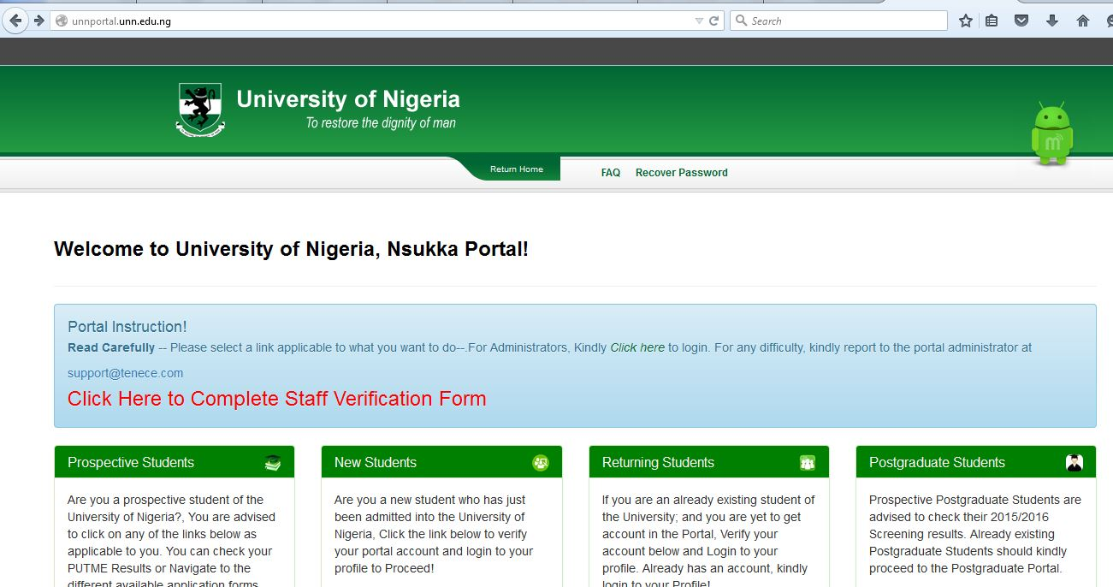
- Click on Online Application
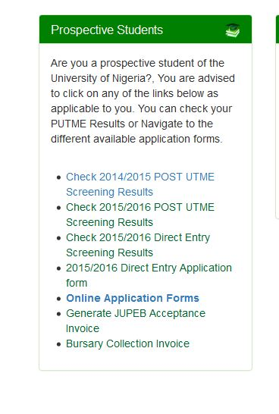
- Go to PG Application Form 2016/17
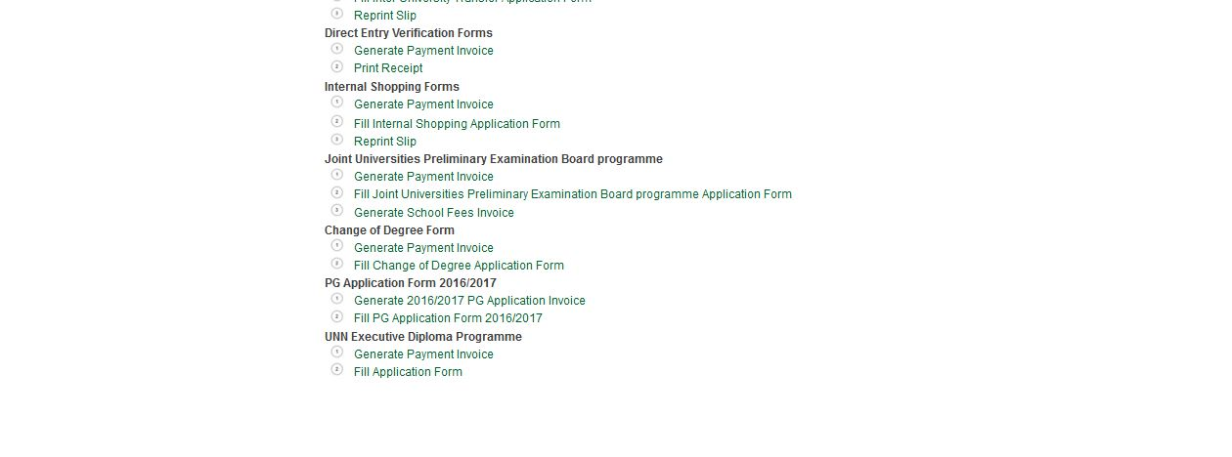
- Click on generate 2016/2017 PG Application invoice.
- Enter your telephone number.
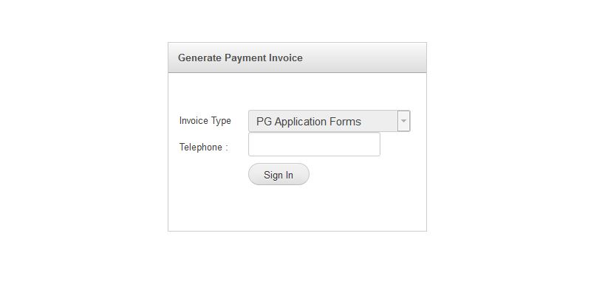
- Click Sign in
- Print your invoice containing your RRR number (Remita Retrieval Reference) and take it to the bank.
- Make payments at the bank.
- Return to step 4 above.
- Click on Fill PG Application form 2016/2017

- Enter Your Remita Number from the bank.
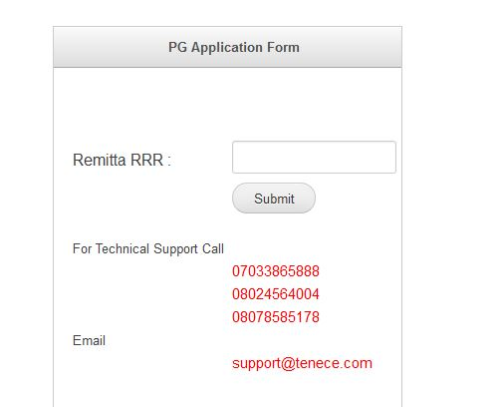
- Fill the online form accordingly.
- Print out a copy of the summary page when the form is completed.
- Submit relevant documents to PG School.
- Send a copy of your academic transcript to the PG School.
- Prepare for the PG CBT entrance Examination.

