CURRICULUM VITAE

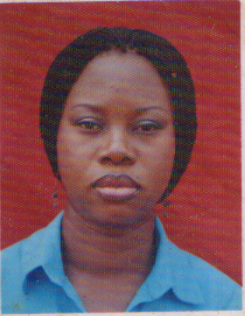

- PERSONAL DATA
- Surname: Umeh (Nee Onugha)
- Other Names: Ogochukwu Ngozi Chidinma
- Contact Address: Department of Pharmaceutical Technology & Industrial Pharmacy, University of Nigeria, Nsukka
- Phone: +2348037989369
- E-mail: ogochukwu.onugha@unn.edu.ng, ogochukwuonugha @yahoo.com
B. QUALIFICATIONS:
Degree Date Obtained Granting Body
M.Pharm (Pharmaceutical Technology) 2012 University of Nigeria, Nsukka
B.Pharm 2005 University of Nigeria, Nsukka
C. Some Selected Publications
- Onugha, O.N and Ofoefule, S. I. The place of Specialized Pharmaceutical Services in Hospital Pharmacy Practice. Nig. J. Pharm. Allied Sci. Res. 1(1): 66 – 73(2011) Nigeria.
- Umeh, O.N.C, Emeje, M. O, Ofoefule, S. I., Effect of some channeling agents on the release of DFK from Hydrophobic polymer matrix. Res. J. Pharm. Bio. Chem. Sci., 3(4): 1173 – 1177 (2012). India.
- Umeh, O.N.C, Ezeagba, J. C and Ofoefule, S. I., Effect of Hydrophilic diluents on the release profile of Grisofulvin from Tablet formulations. Ind. J. Pharm. Sci. 75 (6): 726 – 729 (2013) India.
- Umeh, ONC, Orji I.E and Ofoefule S.I. Effects of particle size and some formulation additives on the dissolution profile of ibuprofen from compressed tablets. Indo Am. J. Pharm. Res. 4 (1): 439-444 (2014) America.

