ABSTRACT
LIPIDS - YOUR FRIEND AND FOE
INAUGURAL LECTURE
BY PROFESSOR I. C. ONONOGBU

Lipids are the least understood and remembered when compared to the other major macromolecular food nutrients carbohydrates and proteins. The lecturer has advocated that in order to understand lipids, one has to look beyond and around himself/herself, and explained what lipids are and what they can do. He went further to discuss his lipid studies which have spanned through epidemiology, health and disease, nutrition, environment, agriculture and biotechnology. In that discourse, he has explained the reason for the geographical variations in lipid levels in different countries: the effect of some staple food-stuffs on health and lipid metabolism, and the role of oilseeds in the economic development of a nation. He was able to develop a formula called diabetic index (Dl) which can be used to determine the ability of foodstuffs to cause diabetes mellitus. He emphasized that misuse, abuse, overuse and under use of lipids will lead to disastrous consequences and therefore one needs to buy right, store right, and eat right in order not to abuse lipids. He also explained the role of lipids in sickle cell anaemia, malaria, heart disease, trypanosoniiasis and mycosis. He surmised that lipids are friends when they are used rightly but can be foes when they are either misused or abused. Therefore, one needs to watch one, lipids in order to live a healthy and happy life.

LIPIDS -YOUR FRIEND AND FOE
Inaugural Lecture by
Professor Ikpendu Christopher Ononogbu
Lipid and Lipoprotein Unit Department of Biochemistry,
University of Nigeria Nsukka.
Anecdote
Mr. Chairman, Ladies and Gentlemen, I will like to share my recent experience with you. One month ago, I was no certain that I would be able to give this lecture because my wife was involved in a serious road accident and was hospitalized at the University of Nigeria Teaching Hospital, Enugu. As a result of this, I was shuttling between Nsukka and Enugu in order to stay with her and make the necessary arrangements for her treatment. During one of my trips, I went to Enugu Sports Club and there I met a friend who decided to buy me a drink. As we were drinking one businessman walked in and sat with us. My friend turned to the businessman and said, "Please meet my friend from U.N.N. He is a professor of Biochemistry." The businessman turned to me and said, "Enyi a si n "ibu Professor of block industry?" In retrospect, I have come to realize that the businessman was right. Biochemistry is a block between biology and chemistry and it is an industry of pathways.
1. THE PATH TO INAUGURAL LECTURES
My predecessors must have defined what inaugural means. They must have all pointed to the fact that inaugural means first or introduction. There are inaugural meetings which are the first meetings that will launch a programme. In the 'Ivory Tower' an inaugural lecture it supposed to be the first lecture that launches a professor into his rightful position in the community of intellectual experts. However, because of the Nigerian situation which for a long time has distorted academic excellence, and the peculiarity of the University of Nigeria as a citadel of learning with "fluid mosaic" administration, these lectures have not been as regular and prompt as they should be. For me in particular, I had-thought that my inaugural lecture and addresses would be restricted to social or cultural aspects like when I gave my inaugural speech as the President of Rotary Club of Nsukka in 1990 or when I gave my inaugural speeches as the President General of Nkpa Community Development Union in 1979 and President of the Steering Committee of African Conference on the Biochemistry of Lipids in 1988. Such inaugural speeches or lectures can, however, be given by anyone. The inaugural lecture in the University system is unique and specific because it is a synthesis of the peculiarities and intellectual achievements and involvement in the life of an academic.
When I came back from London in 1976 after my doctor of philosophy (PH.D) degree as a lecturer II in the Department of Biochemistry, University of Nigeria, Nsukka, I so much looked forward to giving my inaugural lecture. And my calculation was that by 1985 I should be getting ready for my inaugural lecture. I worked very hard to achieve it, but as the cycles of life do not go the way we plan them most of the time, because of human and environmental factors, I did not achieve my target date. When, however, in 19871 was assessed for Readership (Associate Professor) and found qualified, I said to myself, "Ikpendu do not lose hope because you can still make it within the 80's". I did not realize that it was going to be a long wait. Since my Readership appraisal was still in the pipeline, there was nothing I could do about my Professorship (this I later realized was not actually correct because I could have either put in for Professorship during this period of waiting or requested that my earlier submission be upgraded with my additional publications). However, in 1992, my Readership report came out positive and it was only then that I put in for my Professorship. Nevertheless, my Professorship did not come out until 1995, but was announced in 1997, although it was rightly backdated to 1992. So here, I am today celebrating this tortuous journey to my Professorship.
The word inaugural can be broken into two parts: In -which we can consider as a short form of inspiration and Augur -which means portend. So, if we combine these two words, we shall get the meaning of 'Inaugural Lecture' as inspiration-portending lecture. I believe, therefore, that it is a lecture which will inspire the 'new professor' to walk confidently on the exalted sand of academic excellence, and also inspire his junior colleagues to endeavour to move into this...jealously guarded realm. As it has augured well for me today, I pray that it augurs well for my other colleagues. In lipids we say that the cream always rises to the top. I will like to use this opportunity to appeal to those o us who will be required to sit at staff appraisals to ensure that they do not dela) appraisal matters. The University administration should also ensure thai appraisal papers are sent out promptly. There have been rumours of Heads ol Departments and Deans of faculty hiding appraisal papers- the rumours are real and there is no shying away from that fact. I will advise such heads ot departments and Deans to desist from such an ignoble act. I want to believe that this practice is prevalent with those heads of departments and Deans of faculty who became professors as a result of either the 'total man' or sharp practices. 1 can say with no equivocation that the University of Nigeria is the best endowed with men and women of intellect in Nigeria. How long we can maintain this position depends on how we treat the intellectual manpower in the University The University is involved with teaching and research. Teaching is a commoi. factor in the University system but the research aspect is what distinguishes one university from the other. Once there is an impediment in the research activities in a university, that university moves away from a steady state condition to an equilibrium state which automatically leads it to its death. I have been involved in attracting research grants into this university but the way the Bursar's department handles the release of funds to the recipients leaves much to be desired. No university can succeed in its research programmes, without national and international research grants. It is therefore necessary that the university devices a more satisfactory method of administering research grants from outside the university, otherwise many academics who attract grants will not like to continue to do so. A committee needs to be set up to consider this issue. Another area the university should give priority is learned society conference. The University must provide enough funds for learned society conference... The university must provide enough funds for learned society conferences. If you are a senior academic and you have not attended any international conference you are incomplete.
Mr. Chairman, ladies and gentlemen. My name is Ononogbu, that is in the midst of plenty. We are in the midst of plenty in University of Nigeria and indeed in Nigeria. But no one has a child and calls him "I don't care" according to Professor Egudu. Let us not answer I don't care in this midst of plenty. There needs to be a reorientation at Nsukka. I had said in an earlier publication (Ononogbu 1995) that science and indeed knowledge does not thrive in a high entropy (that is a disorderly and chaotic) environment. If you pour oil in
troubled water it gets still, but if you pour oil on fire it rekindles it. So let us use lipids to our advantage. The heart is like the pod of rubber seed. The oil of peace and love flows from it and lubricates the human mind. Let us bring peace and love to Nsukka with the oil from our heart. At this point, I shall take you through my journeys to lipids.
THE JOURNEY TO LIPIDS
When Albert Einstein said that scientists do not remember anything but whatever they remember they never forget, I regarded it as a statement signifying nothing. But now I have come to realize that this statement is a truism. I do not remember much of my childhood but the few I remember have remained vivid and indelible in my memory. At the age of 5 years, that was in 1950,1 was just beginning primary school. My mother the late Madam Uzoma Virginia Ononogbu called me before I left for school and said. "Olu nnam, achorom ka iguo akwukwo ki igho bekke. La uwaghu mbo iguhno akwukwo". This simply translated means "My brother, I want you to read so that you will be like the whiteman. In your previous life you were an illiterate". My mother believed that I was the incarnate other late brother. That statement has never left my mind. Even at a point in my life when I had wanted to abandon academics, the statement bothered me and brought me back to academics. The other experience was during my primary education. In my home town Nkpa the only secondary school most of us at the primary school knew was Methodist College, Uzuakoli. Therefore, in 1957 when I was to take entrance examination to the secondary school, my choice was Methodist College, Uzuakoli. But one morning at my school, Methodist Central School, Okpuhu Nkpa, the headmaster, the late Mr. Albert Egwuonwu Ucheya, announced that he had obtained three forms for entrance to government colleges, and that those three forms were to go to Ikpendu, Ndukwe and Sunday (Ndukwe is now an electrician working with NEPA, Aba, while Sunday is now a judge of the high court ofAbia State). Of course, I did not have any idea of what the headmaster was talking about because for me at that time the only secondary school in the world was Methodist College, Uzuakoli. After the school hours I went to the headmaster and asked, "Sir what will I do with this form"? He said to me "Fill the form and send it. I know that you will pass the entrance". I obeyed and sent the form. A day later, my standard six teacher, Mr. Nwade called me and said to me "I know that you are brilliant but do not go for the entrance examination

to the government colleges. Only those who pass standard six and repeat to prepare for the entrance examination always pass to government colleges". Although, I had confidence that I would pass the entrance examination, this encounter with my teacher started to put doubt in me. When however, I remembered my mother's admonition, I ignored my teacher's advice and went for the entrance examination to Government Secondary School, Afikpo. I had previously taken the entrance to Methodist College, Uzuakoli. When the result for Methodist College, Uzuakoli came out, I passed and my brother made an arrangement with a teacher at the college, Mr. Jack, for me to stay with him during the weekends and holidays to get experience of secondary school life. It was at Methodist College, Uzuakoli that I leamt how to play table tennis. A month later after this arrangement, I got a letter from the Principal of Government Secondary School, Afikpo, Mr. Charles Low, informing me that I had passed the entrance examination and inviting me for interview at Afikpo. I took the letter to the headmaster. When he read the letter he exclaimed "I knew you would do it". I said, "But Sir, I have already passed entrance to Methodist College, Uzuakoli". He retorted, 'Are you mad? How can you leave a government college and go to another school"? That is how Ikpendu Ononogbu found himself at Government Secondary School, Afikpo in 1958. In my class at government secondary school were A.B.C. Nwosu (now a Professor), Young Nwafor, James Nwamuo, Stephen Anga, Benson Bawak, Uka Ikpeama, Osita Mogbo (now a Professor), Godson Nwaogu, Onwunyiriuwa Wachukwu, Promise Abuwa, Donald Egbuonu, Michael Arinze and Irem Oti just to name a few. Everyone of us wanted to enter university after the secondary school to read Medicine or Maths - Maths magic (as we referred to Mathematics and Engineering at that time). Notwithstanding our inclination to science we never forgot our arts subjects. Latin was one of my favourites and the story that remained indelible in my memory is the story of the horse and the goose which we read in Latin Clarendon. It is a story of the horse and the goose drinking water together. The goose turned to the horse and said, "why do you despise me? I inhabit three worlds; I can walk on land; I can swim on water; and I can fly in the air. But you can only walk on land". The horse turned to the goose and replied, "for you, whether you walk on land; whether you swim on water; and whether you fly in the air, you do all of them imperfectly and ridiculously too. I am the master of the land". When we translate the statement of the goose into Latin it will sound like "Cur me tanta superbia spanis? tres elementos habito;
10
- - ^bulare; in aqua nature; in aere volare ". For the horse's reply ft will be as follows; "At tu, sive ambulas, sive natas, sive volas, omnia indicenta, omnia redicule fads. Magister terra sum". It was my interest in Latin that helped me teach Latin in addition to general science in Stella Maris College, Port-Harcourt for 9 months before going to the University oflbadan in 1965 for my undergraduate studies. At Ibadan I was to read Physiology but in our first year we had to study physics, chemistry and zoology. Unfortunately, the first Nigerian military coup d'etat took place in January 1966. But we were able to finish our first year examination in spite of the crisis and went on holidays in July 1966. In September 1966 when I was to leave for Ibadan for the 1966/67 academic year, Lt. Col. Ojukwu, the then military governor of Eastern Region made the announcement that any person leaving the region to other regions was doing it at his or her own risk. I had to abandon my trip to Ibadan. There was an announcement later that all students from other universities, who did not want to go back to their former universities should go to the University of Nigeria to register. I travelled to Nsukka twice but did not register because I could not reconcile myself with being an Nsukka graduate. At that time most of us despised Nsukka as the horse despised the goose. However, at the third trip to Nsukka I got myself registered in the Department of Chemistry. Unfortunately again, the Nigerian Civil War broke out after we had just finished the 1966/67 session. I remained in Biafra throughout the war in research and production, and I am happy that I came out of that war alive and unmaimed. Two people I have to pay tribute to for my survival at that war are Mr. Fabian Ekezie and Professor Oleka Udeala. Mr. Fabian Ekezie saved me from a bomb attack at Methodist College, Uzuakoli, where our unit was operating. On the 17th of September 1968,1 was about to go into the lab to prepare matches, but Fabian talked me into following him to Umuahia. Just as we left the premises for Umuahia, the lab in which I was to work was bombed and destroyed by a) Nigerian bomber plane. Again, when Uzuakoli was occupied by the Nigerians in 1969, I was in charge of the science group at Okagwe Ohafia and was unaware of the fall of Uzuakoli. However, on 30th March 1969 Professor Oleka Udeala came to Okagwe and requested that we should go to Uzuakoli to see what was happening. We left in his fiat car through his home town, Item. On our* way we ran into an ambush by the Nigerian soldiers. It was only his familiarity with the terrain and his dexterity in driving that saved us from being capturecl alive or being shot to death. After these two incidents, I said that I was going tdf
11 I
survive the war no matter how long it lasted. I finally succeeded in leaving Ohafia through Arochukwu to Amakohia, Owerri from where I was redeployed to the BOFF (Biafran Organization for Freedom Fighters) camp at Amaogwugwu, Umuahia to look after the science group there. When Umuahia fell to the federal troops, I moved my group to near Anara. Incidentally that is the paternal home of my dear wife, Grace Onuwabuchi Ononogbu (nee Ihekaire). So it was a case of to Anara with love. However, we did not meet until 1972 and we got married in 1973.
Some people may ask, "why this long story?, what has it got to do with lipids"? In order to understand lipids you have to cover a long distance because lipids have long structures, and to shorten their structure will give you entirely a different compound. Similarly, if you cut my journey short you will get a different and distorted picture. So to continue the journey, at the end of the civil war in 1970,1 found myself back to the Department of Chemistry, University of Nigeria, Nsukka. This time around the best academicians and students from all the other universities had come back to the University of Nigeria. This gave entirely a different dimension to the academic stature of the University of \:geria. In 19711 graduated in Chemistry with B.Sc. (Hons) second class upper division. My academic adviser was Professor Chimere Ikoku whose lecture on neighbouring group participation inspired me a lot. My research project supervisor was Professor Charles Okafor, and my project topic was "Survey of the more useful reductive methods in organic chemistry with a view to developing the most convenient route to sterically hindered 0-aminohydroxy and mercapto compounds". These are intermediate compounds for medicinal compounds. It was this subject that motivated me to go into biochemistry . Immediately after my graduation, there was an advertisement for junior research fellows for which I applied to the Department of Biochemistry. I was called for an interview, but before I received the result of the interview, I had been offered a job of pupil chemist in Nigeria Paper Mill, Jebba. I was just contemplating taking the job at the paper mill when the letter offering me the job of junior research fellow at the Department of Biochemistry, University of Nigeria, Nsukka arrived. My confusion then was which job offer to accept. The salary to- the paper mill was higher than that for the University junior research fellow salary. This higher offer of salary by the paper mill looked very attractive to me r-: I remembered my mother's admonition and convinced myself that going to T;.bba would not make me realize my mother's dream. So off to Nsukka I went
12
and started work on 14th December, 1971 as a Junior Research Fellow in the Department of Biochemistry. In 1973 I gained admission to the University of London to study for a doctor of philosophy (Ph.D) in the Royal Postgraduate Medical School, Hammersmith Hospital London. I was to report at the Department of Chemical Pathology and Biochemistry. When I arrived at the Department, the Head of Department, Professor I.D.P. Wootton, introduced me to the different sections of the Department which were: The enzyme section, The lipids section and the protein section. For the first one month I had to go to all these sections to familiarize myself with the sections before making up my mind on where to specialize in. I looked at the sections and said to myself, "You know enzymes, you know proteins, but what is lipid"? To compound the situation, the section did not just stop with the word lipid but had a double barrelled name Lipids and Lipoproteins. I decided to choose Professor Barry Lewis, the Head of the Section as my supervisor. This is my long journey to lipids.
When I was trying to choose the topic for my inaugural, I thought of many captions, such as Lipid Biochemistry in the national economy, Lipid biochemistry in health care delivery, Lipids in biotechnology and industry or Lipid biochemistry as a tool for understanding science. I even thought of the caption like Lipid biochemistry- The romance of the 90's. But some of my experiences, have given me the impression that choosing any of the above captions, or even any other would amount to jumping the gun. For example, when I was organizing the African Conferences on the biochemistry of Lipids, one Professor asked me, is this your lipid the short form of millipede?" Another member of staff in the university asked a Professor who was attending the conference, "please can you tell me what this lipid is?" The Professor told the enquirer that lipids are fats and oils. The enquirer then retorted, "why doesn't he just say that instead of confusing us with the word Lipids"? I was even most surprised in 1993 when I went to Canada. I was coming out of the hotel carrying the conference bag of the Second African Conference on the Biochemistry of Lipids, when a whiteman accosted me, and pointing at the bag asked, "what is lipids"? I was almost dumbfounded, but I recovered quickly and said to him... "lipids are fats and oils" just to get away.
Mr. Chairman, ladies and gentlemen, the title of my lecture is Lipids-your friend and foe.
13
3. THE NATURE AND DEFINITION OF LIPIDS
From creation man has always depended on food for his/her existence. Bu among the three ma) or macromolecular food nutrients protein, carbohydrate anc lipid, the lipids have been the most neglected and almost avoided and unknown especially in the developing countries. Lipid is derived from the Greek won Lipos meaning fat, and has gone through various names such as Lipin an< Lipoid. At an early stage it was even spelt with an e at the end of the d, thu;
representing it as Lipide. This evolution in the nomenclature of lipids als< underlines the significance of the similarities and differences of lipids in th< biological and geological evolution.
Look Beyond Yourself

Look beyond yourself Where ever you may be;
Look beyond yourself Is the only way to live. For the world around us, With so much to be done Make a plan for eating A plan for every nutrient.
Look beyond yourself Help those who need to live Look beyond yourself Save people every where • We are called to do our part This mission to fulfil;
Building here a better world With fats and oil and surfactant. Look beyond yourself Make a world that ought to be;
Look beyond yourself You are the cream of the society.
Generally, species within a genus are known to have a close relationship in thei lipids. Thus, the two major reasons for the occurrence of lipids appear to b genealogy and function. Lipids can therefore play a significant role i:
14

arc¹- _.es because they can offer an opportunity for the exa' -.£ existence of life, since their structures and biosynthesis are nov. - -—; -:ood and unlike genetic material DNA (deoxy nucleic acid) and enzymes, ifaey perform the functions which benefit the organism. Man needs to look beyond hnnselfherself and around himsel^erself to appreciate the importance oflipids. It is on this concept that this lecture on lipids will start with an adaptation of the Rotary international theme song "look beyond yourseIC and followed by an adaptation of my earlier publication titled "I am a child of tomorrow". These two adaptations emphasize the need for the sustainabilily oflipid studies in order to create a healthy environment. Having looked beyond ourselves and seen what lipids are advocating, it is necessary to now look around us in order to be familiar with the subject of this lecture. This is why the second part of the message of lipids is titled "I am a child of tomorrow".
I AM A CHILD OF TOMORROW
Hello fellow lipidologists and lovers of good health. I am Ikpendu Ononogbu. They call me Mr. Lipid. You may ask, "what is lipid? and why do we have to worry about lipids since they are low in the blood of Africans"? Yes your questions are reasonable.
Without defining lipids I will just tell you that you see lipids and deal with lipids everyday. The fats and oils in your food are lipids; the egg you eat contains cholesterol and lecithin which are lipids; the meat you eat contains cholesterol and fats which are lipids. The milkyou drink contains fats which are lipids, the margarine and the butter you apply to your bread contains fats which are lipids; the oil seeds which we eat (remember palm kernel, chestnut, groundnut etc), the fish oil and the vegetable oils which you use for food are lipids. I can go on and on but at the end of it all you will notice that you have been familiar with lipids without knowing that you have been dealing with lipids all your life. The lipids are always with you and there is no running away from them. You just have to understand what they do and how to use them, and you will be assured of a healthier life.
Lipids can however be defined simply as substances that dissolve readily in non-aqueous solvents but do not dissolve in or are sparingly soluble in aqueous solvents and constitute in part of the membrane structure and are one of the major food constituents. Some of the functions oflipids are the carriage in the body of fat soluble vitamins (A.D.E.K.); the provision of energy to the
15
body, and the provision of mechanical support against trauma and injury in the body when they are deposited at special areas called adipose tissue. Lipids have a tremendous effect on the body physiology. The fatty acids which are components of the phospholipids and cholesterol ester modulate membrane fluidity and function; the prostaglandins constrict and dilate the vascular system; the thromboxanes, prostacyclins and the leukotrienes play significant roles in coronary diseases and in inflammation, and the triacylglycerols, otherwise referred to as fats and oils are the main sources of energy in lipid metabolism and they give palatabilitv to food.
Now that you have known what lipids are, I can hear you sighing and saying, "if these are what we call lipids why bother everyone? We do not even have enough of them so our emphasis should be on having more of them. We should be talking of how to immunize our children and their mothers against communicable diseases. We should not be talking about lipids. The environment is dirty and people are dying of diseases, hunger and malnutrition. Lipids! it is all nonsense". Yes I tell you that you may be right in holding this opinion but sit back, read or listen carefully to wh?.* *n'¹ ws and reflect on a few
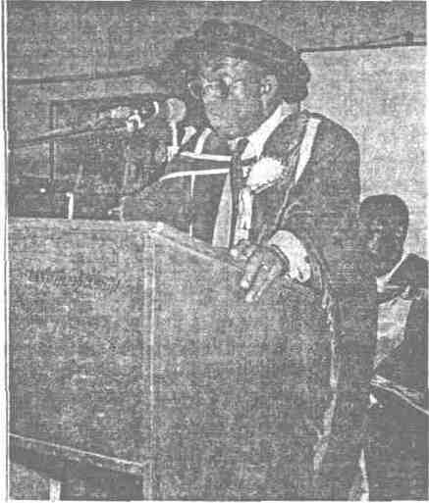
Professor Ononogbu delivering his inaugural lecture
16
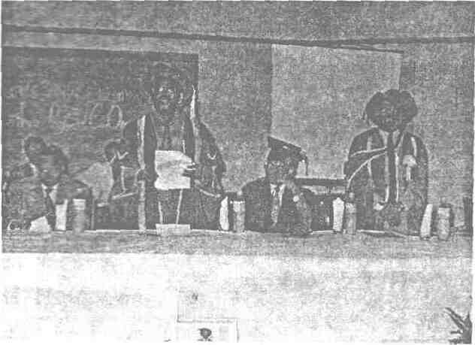
Ag. V.C., Prof. Mbanefoh, the inaugural lecturer (Both standing) and some dignitaries at the lecture
We eat today and what we eat sustains us till the next day. What we eat today affects our health and behaviour for tomorrow. We live for today and tomorrow. Communicable disease is a child of today. Dirty environment is a child of today. Hunger and malnutrition are children of today. But one thing common to them is that they are non living children The living child is crying for protection from his non-living counterparts. So the living child must be saved for tomorrow when his non-living counterparts must have disappeared. We are told that the name of the living child is today and he cannot answer tomorrow. We must however take care of today and prepare for tomorrow.
Your serum cholesterol level is a child of tomorrow. When you allow this child to grow so big as to get into your blood stream to be deposited in your blood vessels, then you are heading towards heart disease (sudden death, coronary atherosclerosis). Do not allow the child of tomorrow to grow very big. How can you do this? You can do it by watching the type of fats and oils you eat; the amount of fatty foods you eat and the amount of high cholesterol foods (eggs, and other animal proteins) you eat. A moderate amount of animal protein,
17
more of poultry food, sea food, vegetables and fruits will do you more good. Your carbohydrate should contain sufficient fibre (roughage). Always eat for a healthy heart and you will have no problems. Do not, of course, forget to do one form of exercise or another (from walking or jogging to tennis and other strenuous exercises). But always remember to do the exercise that, is equal to your target heart rate. Be alive and well.
By the way, do you know what your serum cholesterol number is? Go to any medical centre or see your doctor to find out what your number is. You may also call at the lipid and lipoprotein unit of the department of biochemistry, University of Nigeria, Nsukka to get information on your cholesterol status. If your serum cholesterol number is 150-180mg/100ml, then you do not have to worry. Just ensure that you check it every year. You are on the safe side of heart disease arising from high blood cholesterol. If your number is 180-200mg/100ml, you are on the borderline and you must watch your lipids. Check your cholesterol number every six months.
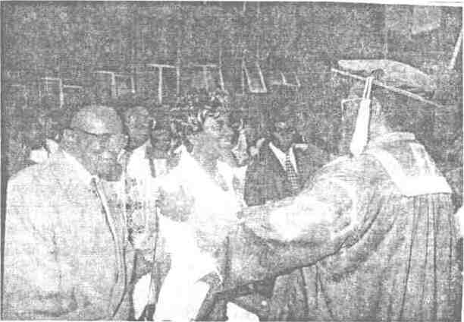
The Ag. Vice-Chancellor congratulating Mrs Ononogbu at the lecture
18

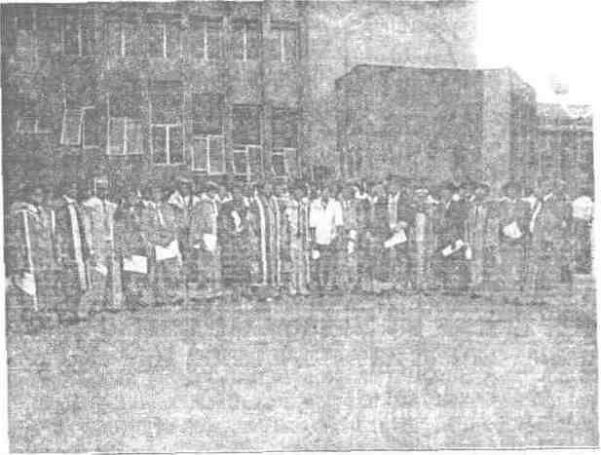
Your chances of moving towards heart disease arising, from high serum cholesterol are high, if you do not control your lipid intake. If your cholesterol number is greater than 200mg/ 100ml, then you have a problem. You must see your doctor immediately for counselling. You must have a big heart that will be too small to sustain your prolonged existence. The choice is yours but this is the time to prepare for tomorrow. I am a child of tomorrow. I am a voice crying in the wilderness. Hear me now and your heart will be preserved for tomorrow. Forget about me now and the consequences will be severe and sudden. When tomorrow comes, do not say I did not tell you.
4. MY LIPID STUDIES
4.1 Metabolic utilization and Epidemiology ofLipids and Lipoproteins
Outside the living body we might talk of lipids as discrete entities but in the human body lipids are transported in association with proteins as a complex molecular aggregation called lipoproteins. These lipoproteins are classified as chylomicrons very low density lipoproteins (VLDL), low density lipoproteins (LDL) and high density lipoproteins (HDL) as shown in figure 1

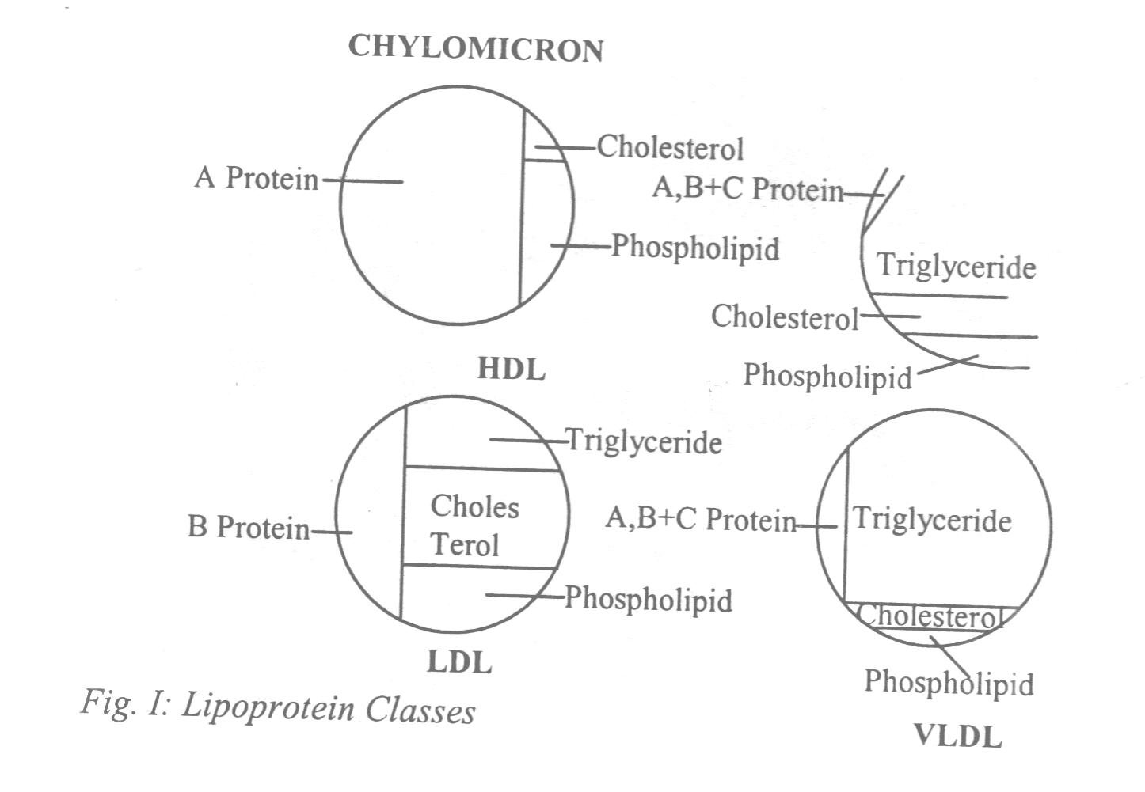

These molecular species regulate the lipid metabolism in the body and vary in different physiological and disease conditions. The chylomicron is responsible for the transport of exogenous (i.e. dietary) lipids, while VLDL is the medium for the transport of endogenous lipids, especially the triacylglycerols. LDL is the main vehicle for the transportation of cholesterol. So LDL-cholesterol is referred to as "bad cholesterol" because it is proatherogenic (i.e. promotes coronary heart disease-CHD). HDL however is involved with phospholipid metabolism and has the highest protein content. It is the medium for the removal of cholesterol from the tissues and therefore has a high capacity to solubilize a great percentage of cholesterol. This is why HDL - cholesterol is called "good cholesterol", because it's antiatherogenic (i.e. it prevents coronary heart disease). One of the early problems lipidologists had was the isolation and separation oflipoproteins. However, with the introduction of ultracentrifugation (De L'alla and Gofman 1954), and electrophoresis (Noble 1968) it was possible to separate these lipoproteins. The difficulty with ultracentrifugation is that it is time consuming and expensive while electrophoresis is basically a qualitative rather than a quantitative method. When I therefore got involved with lipid studies, my first assignment was to develop an easy and cheap method for lipoprotein separation. This I succeeded in achieving by the use of polyelectrolytes to precipitate lipoproteins. The result of this study has been
published in international journals (Ononogbu and Lewis 1976). Previously lipid related diseases associated with increase in lipids in the blood plasma were just classified as hyperlipoproteinaemias or hyperlipidaemias and could not be related to lipoprotein ratios, but my research and research findings in the 1970's and 1980's gave an insight into the fact that:
(a) HDL may be more effective as an antiatherogenic agent in the younger age groups < 60 . years) (Ononogbu 1977).
(b) The triacylglycerol to cholesterol ratio of the serum determines the VLDL concentration and behaviour (Ononogbu 1978).
(c) There is a sex linkage of some of these traits and a possible polygenic type of inheritance (Ononogbu 1979a) and
(d) Immunological test cannot be used to differentiate between abnormal
VLDL and normal VLDL (Ononogbu 1982). In terms of variation of lipids and lipqproteins in different geographical locations, a number of studies had indicated differences in lipids in communities (Keys et al 1954, Sharper and Jones 1962). These studies except that ofTaylor (1971) were mainly on whites and other countries. But with my studies (Ononogbu 1979b, 1981) relationship in lipids and lipoprotein between Nigerian communities and European communities and cut-off points or baseline levels were established. In Table I is shown a typical example of lipid and lipoprotein concentrations in Nsukka and London.

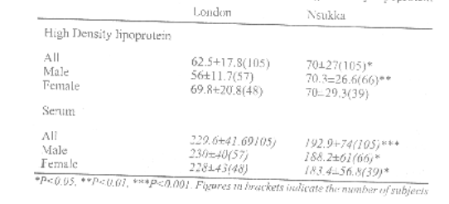
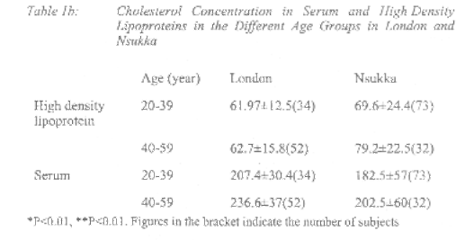

These studies show that although other risk factors may interact with cholesterol concentration to produce the population differences, nutrition and life style are most noticeable determinants of population differences in lipids and lipoproteins; the high level of serum high density lipoprotein cholesterol in the Nigerian population may be responsible for the low incidence of coronary heart disease when compared to other western countries; although total serum cholesterol determination alone does not indicate whether there is increased LDL or HD1 cholesterol concentration, it is the index that determines whether lipoprotein phenotyping is necessary or not. A study on the comparison oflipid concentration with animals, especially the local cows (Ononogbu and Nwaenyi 1987) showed also that the percentage ofesterified plasma cholesterol is higher in the humans than in the cows, a result which can be attributed to the higher concentration of lecithin cholesterol acyltransferase (LCAT) in man than in these animals..
4.2 Lipids in Nutrition
In the previous section I considered the geographical variation in plasma lipids. Apart from genetic and environmental factors which contribute to these variations, diet plays an important role in plasma lipid and lipoprotein concentrations. This prompted me to look at some staple diets in Nigeria to see how they affect lipid concentration in experimental animals. The three food sources which I concentrated on were gari, cocoyam and yam.
My studies with the foodstuffs showed that gari diet (Ononogbu and Emole 1978) lowers blood cholesterol and in relation to yam and cocoyam in lowering of blood lipids the situation is that for plasma cholesterol:

cocoyam>yam>gari. while also in the increase in weight and therefore in triacylglycerol the sequence is cocoyam>yam>gari (Ononogbu 1988). In terms of the concentration of lipids that are involved in brain function my studies showed that animals fed with gari have lower cerebroside concentration especially at a level of 16% (by weight) of gari incorporation in the diet (Ononogbu and Azukaeme 1988). These cerebrosides and gangliosides are important determinants of brain function as a result of their fatty acid composition. For example, the fatty acids alpha linolenic acid (ALA) which are contained in them help in brain development and function while' the docosahexaenoic acid in them is important in visual acuity and development. m another study (Ononogbu 1988a), my results showed that adipose tissue lipoprotem lipase activity decreases with gari feeding. This decrease in the enzyme activities has also been shown to contribute to the formation of fatty streaks in the aorta of rats fed with gari (Onyeneke and Ononogbu 1989). However, further studies (Ononogbu and Okpara 1986) showed that feeding of gari to animals decreases LCAT activity. Thus there is decrease in esterification of cholesterol leading to less cholesterol ester deposition in the tissues. Cholesterol ester is the offending lipid in atherosclerosis. One important observation in these nutritional studies is that these carbohydrates must be taken with proteins otherwise there will be adverse effects. For example, if garri is taken without adequate protein supplementation there will be fatty liver induction (Ononogbu 1980). This process is shown in figure 2.

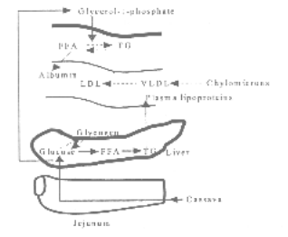

Figure 2: Fatty Liver induction due to gari (cassava) feeding.
Schematic representation of fatty liver induction by cassava (----) Impaired pathway. FA, free fatty acid, TG triglyceride. LDL, low density lipoprotein. VLDL, very low density lipoprotein.

20

